Bachelor of Computer Applications (BCA) Programme

Major Project Report

BCA Sem VI

AY 2023-24

Project Title: ***WellCare Hospital***

*by*

|  |  |
| --- | --- |
| Exam No. | Name of Student |
| 5917 | Goyani Harsh Nareshbhai |
| 5773 | Balar Kremi Sureshbhai |
| 5867 | Dobariya Khushi Kamleshbhai |
| 5871 | Dobariya smeet Ghanshyambhai |

Project Guide by :

### Prof. Jaimini Patel

**Acknowledgement**

The success and outcome of this project required a lot of guidance and assistance from many people, and we are extremely fortunate to have gotten this all along with the completion of our project work. Whatever we have done is only due to such guidance and assistance.

We would not forget to thank I/C Principal Dr. Aditi Bhatt, IQAC coordinator and trust representative Dr. Vaibhav Desai, Head of BCA Department Dr. Vimal Vaiwala and Project guide Prof. Jaimini Patel and all other assistant professors, who took a keen interest in our project work and guided us all along till the completion of our project work by providing all the necessary information for developing a good system.

We are extremely grateful to **her** for providing such nice support and guidance, though **she** had a busy schedule managing the college dealings.

We are thankful and fortunate enough to have gotten support and guidance from all the teaching staff in the Bachelor of Computer Application Department, which helped us successfully complete our project work. Also, we would like to extend our sincere regards to all the non-teaching staff of the Bachelor of Computer Application Department for their timely support.

Goyani Harsh Nareshbhai (5917) Balar Kremi Sureshbhai (5773) Dobariya Khushi Kamleshbhai(5867)

Dobariya Smeet Ghanshyambhai(5871)

I N D E X

|  |  |  |
| --- | --- | --- |
| **Sr. No** | **Description** | **Page No.** |
| 1 | Introduction | 1 |
|  | 1.1 Project description | 2 |
|  | 1.2 Project Profile | 6 |
| 2 | Environment Description | 8 |
|  | 2.1 Hardware and Software Requirements | 13 |
|  | 2.2 Technologies Used | 15 |
| 3 | System Analysis and Planning | 17 |
|  | 3.1 Existing System and its Drawbacks | 18 |
|  | 3.2 Feasibility Study | 19 |
|  | 3.3 Requirement Gathering and Analysis | 19 |
| 4 | Proposed System | 20 |
|  | 4.1 Scope | 20 |
|  | 4.2 Project modules & functionalities Constraints | 21 |
| 5 | Detail Planning | 22 |
|  | 5.1 Data Flow Diagram / UML | 22 |
|  | 5.2 Process Specification / Activity Flow Diagram | 24 |
|  | 5.3 Data Dictionary | 29 |
|  | 5.4 Entity-Relationship Diagram / Class Diagram | 46 |
| 6 | System Design | 49 |
|  | 6.1 Database Design | 49 |
|  | 6.2 Directory Structure | 50 |
|  | 6.3 Input Design | 51 |
|  | 6.4 Output Design | 51 |
| 7 | Software Testing | 72 |
|  | 7.1 Unit Testing | 72 |
|  | 7.2 Integration Testing | 73 |
|  | 7.3 System Testing | 74 |
| 8 | Limitations and Future Scope of Enhancements | 76 |
| 9 | Bibliography & Reference | 78 |



## EXECUTIVE SUMMARY

Hospital Management System provides the benefits of streamlined operations, enhanced administration & control, superior patient care, strict cost control and improved profitability. HMS is powerful, flexible, and easy to use and is designed and developed to deliver real conceivable benefits to hospitals. More importantly it is backed by reliable and dependable support.

The project ‘Hospital Management System’ is based on the database, object oriented and networking techniques. As there are many areas where we keep the records in database for which we are using MY SQL software which is one of the best and the easiest software to keep our information. This project uses JAVA as the front-end software which is an Object Oriented Programming and has connectivity with MY SQL.

Hospital Management System is custom built to meet the specific requirement of the mid and large size hospitals across the globe. All the required modules and features have been particularly built to just fit in to your requirement. This package has been widely accepted by the clients in India and overseas. Not stopping only to this but they are highly satisfied and appreciating. Entire application is web based and built on 3 tier architecture using the latest technologies. The sound database of the application makes it more users friendly and expandable. The package is highly customizable and can be modified as per the needs and requirements of our clients. Prolonged study of the functionalities of the hospital and its specific requirement has given it a wonderful shape both technically and usability wise. It covers all the required modules right from Patient Registration, Medicine details, Doctor, Wards, , Admin, Store, Patient appointment, bill payment, record modification, discharge details etc.



## INTRODUCTION TO THE STUDY

###### 1.1 Introduction:

Human Body is a very complex and sophisticated structure and comprises of millions of functions. All these complicated functions have been understood by man him, part-by- part their research and experiments. As science and technology progressed, medicine became an integral part of the research. Gradually, medical science became an entirely new branch of science. As of today, the Health Sector comprises of Medical institutions

i.e. Hospitals, HOSPITALs etc. research and development institutions and medical colleges. This the Health sector aims at providing the best medical facilities to the common man.

###### Project Summary

Still being a developing nation India has seen a tremendous growth of the Health sector in the field of research as well as in the field of development of numerous large and small scale Hospital institutions still lacking in inter-structure facilities. Government of India has still aimed at providing medical facilities by establishing hospital. The basic working of various hospitals in India is still on paper as compared to hospitals in European countries where computers have been put in to assist the hospital personals their work. The concept of automation of the administration and management of hospital is now being implemented in India also, with large hospitals like APPOLO and AIIMS in Delhi, ESCORTS in Chennai, having automated their existing system.

Our project is based on the above concept i.e. automation of Administration and Management of Hospital. The project has been developed keeping in-view the following aspects: -

1. Working environment of the Hospital.
2. The thought-process and attitude of Indian people.
3. The literacy rate of India.
4. The Existing system, being used in the majority of Hospitals.
5. The availability of Infra-structural facilities likes finance, skilled personals, and working environment.



##### DEFINITION OF PROBLEM:

Since HOSPITAL is associated with the lives of common people and their day-to-day routines so I decided to work on this project.

The manual handling of the record is time consuming and highly prone to error. The purpose of this project is to automate or make online, the process of day-to-day activities like Room activities, Admission of New Patient, Discharge of Patient, Assign a Doctor, and finally compute the bill etc.

I have tried my best to make the complicated process **Hospital Management System** as simple as possible using Structured & Modular technique & Menu oriented interface. I have tried to design the software in such a way that user may not have any difficulty in using this package & further expansion is possible without much effort. Even though I cannot claim that this work to be entirely exhaustive, the main purpose of my exercise is perform each Hospital’s activity in computerized way rather than manually which is time consuming.

I am confident that this software package can be readily used by non-programming personal avoiding human handled chance of error.

##### MODULES:

Hospital Management System is web application for hospital which manages doctors and patients. In this project, we use PHP and MySQL database.

The entire project mainly consists of 3 modules, which are

* Admin module
* User module (patient)
* Doctor module

###### Admin module:

* + - 1. **Dashboard:** In this section, admin can view the Patients, Doctors, Appointments and New queries.
      2. **Doctors:** In this section, admin can add doctor’s specialization and mange doctors (Add/Update).
      3. **Users:** In this section, admin can view users detail (who take online appointment) and also have right to delete irrelevant user.



* + - 1. **Patients:** In this section, admin can view patient’s details.
      2. **Appointment History:** In this section, admin can view appointment history.
      3. **Contact us Queries:** In this section, admin can view queries which are send by users.
      4. **Doctor Session Logs:** In this section, admin can see login and logout time of doctor.
      5. **User Session Logs:** In this section, admin can see login and logout time of user.
      6. **Reports:** In this section, admin can view reports of patients in particular periods.
      7. **Pages:** In this section, admin can update the about us and contact us page details.
      8. **Patient Search:** In this section, admin can search patient with the help of patient name and mobile number.

Admin can also change his/her own password.

###### User module (patient):

* + - 1. **Dashboard:** In this section, patients can view the his/her profile, Appointments and Book Appointment.
      2. **Book Appointment:** In this section, Patient can book his/her appointment.
      3. **Appointment History:** In this section, Patients can see his/her own appointment history.
      4. **Medical History:** In this section, Patients can see his/her own appointment history.

User can update his/her profile, change the password and recover the password.

###### Doctor module:

* + - 1. **Dashboard:** In this section, doctor can view his/her own profile and online appointments.
      2. **Appointment History:** In this section, Doctor can see patient’s appointment history.
      3. **Patients:** In this section, doctor can manage patients (Add/Update).
      4. **Search:** In this section, doctor can search patient with the help of patient name and mobile number.

Doctor can also update his profile, change the password and recover the password.



##### 1.8 NEED:

I have designed the given proposed system in the JSP to automate the process of day to day activities of Hospital like Room activities, Admission of New Patient, Discharge of Patient, Assign a Doctor, and finally compute the bill etc., online facilities to the multiple users etc.

The complete set of rules & procedures related to Hospital’s day to day activities and generating report is called **“HOSPITAL MANAGEMENT SYSTEM”.** My project gives a brief idea regarding automated Hospital activities.

The following steps that give the detailed information of the need of proposed system are:

Performance: During past several decades, the hospital management system is supposed to maintain manual handling of all the hospital daily activities. The manual handling of the record is time consuming and highly prone to error. To improve the performance of the hospital management system, the computerized hospital management system is to be undertaken. The computerized hospital project is fully computerized and user friendly even that any of the hospital’s members can see the patient’s report and the doctor’s report.

Efficiency: The basic need of the project is efficiency. The project should be efficient so that whenever a new patient is admitted, and automatically a bed is assigned and also a doctor is assigned to the patient according to the patient’s disease. And if any patient is



getting discharged, the bed assigned to him/her should automatically free in the computer.

Control: The complete control of the project is under the hands of authorized person who has the password to access this project and illegal access is not supposed to deal with. All the control is under the administrator and the other members have the rights to just see the records not to change any transaction or entry.

**1.2 Project Technical Profile :**

|  |  |
| --- | --- |
| **Project Title:** | Hospital Management System |
| **Definition :** | A Hospital Management System (HMS) is a comprehensive software solution designed to streamline and optimize the various administrative and clinical processes within a healthcare facility.  This system integrates multiple functionalities, including patient management, appointment scheduling, billing and invoicing, inventory management, and medical records management, into a  single platform. |
| **Developed For :** | S.D. J. International College, Vesu, Surat. |
| **Project Guide(s):** | Prof. Jaimini Patel |
| **Front End:** | Html, CSS, JS |
| **Scripting language :** | PHP |
| **Back End :** | Microsoft SQL |



|  |  |
| --- | --- |
| **Operating System:** | Microsoft Windows 11 |
| **Designing Tools** | Bootstrap |
| **Tools used for ERD & DFD** |  |
| **Submitted By** | Goyani Harsh Nareshbhai Balar Kremi Sureshbhai Dobariya Khushi Kamleshbhai  Dobariya Smeet Ghanshyambhai |



**2.Environment Description**

###### 2.1 Requirement analysis and fact gathering

Requirement analysis and fact-gathering techniques play a crucial role in the development of a Hospital Management System (HMS), ensuring that the final solution meets the needs and expectations of healthcare providers, administrators, and patients. This process involves systematically gathering and analyzing requirements, understanding the workflows and challenges within the hospital environment, and identifying the key functionalities and features necessary for an effective HMS.

One common technique used in requirement analysis for an HMS is stakeholder interviews. This involves conducting structured interviews with various stakeholders, including doctors, nurses, administrative staff, IT personnel, and patients, to gather insights into their specific needs, pain points, and desired functionalities. Through these interviews, developers can gain a deeper understanding of the hospital's operations, workflows, and unique requirements, which helps in designing a tailored solution that addresses specific challenges and enhances efficiency.

Another important technique is workflow analysis, which involves mapping out the existing processes and workflows within the hospital, from patient registration to discharge, to identify bottlenecks, inefficiencies, and areas for improvement. By analyzing these workflows, developers can uncover opportunities to streamline processes, automate repetitive tasks, and optimize resource utilization, thereby improving the overall efficiency and quality of care delivery.

Additionally, observation and shadowing can be valuable techniques for gathering firsthand insights into how hospital staff and patients interact with existing systems and processes on a day-to-day basis. By observing staff as they perform their duties and interacting with patients throughout their healthcare journey,



developers can gain valuable insights into pain points, usability issues, and areas where the HMS can make a meaningful impact

Furthermore, requirements workshops and brainstorming sessions can be effective techniques for eliciting requirements and generating ideas collaboratively with key stakeholders. By bringing together cross-functional teams to discuss and brainstorm potential features and functionalities, developers can ensure that the HMS meets the diverse needs and requirements of all stakeholders while fostering a sense of ownership and buy-in from the entire team.

Overall, requirement analysis and fact-gathering techniques are essential for gathering insights, understanding the needs and challenges of the hospital environment, and defining the scope and specifications of an HMS that aligns with the goals and objectives of the healthcare organization. By leveraging these techniques effectively, developers can ensure the successful development and implementation of a Hospital Management System that enhances efficiency, improves patient care, and meets the evolving needs of the healthcare industry.

###### 2.2 Feasibility study:

* + - A feasibility study assesses the technical, operational, and economic viability of implementing the hospital management system.
    - Technical feasibility evaluates whether the necessary technology exists to support the proposed system, including hardware, software, and networking infrastructure.
    - Operational feasibility examines whether the proposed system aligns with hospital workflows, processes, and user requirements.
    - Economic feasibility assesses the cost-effectiveness of implementing the system, considering development costs, maintenance expenses, and potential return on investment.



* + - The hospital management system may utilize technologies such as server-based architecture, web-based interfaces, database management systems, and programming languages such as Java, .NET, or Python.
    - The feasibility study ensures that the hospital management system meets technical requirements, operational needs, and financial constraints before proceeding with development and implementation.



**2.3 Timeline chart**

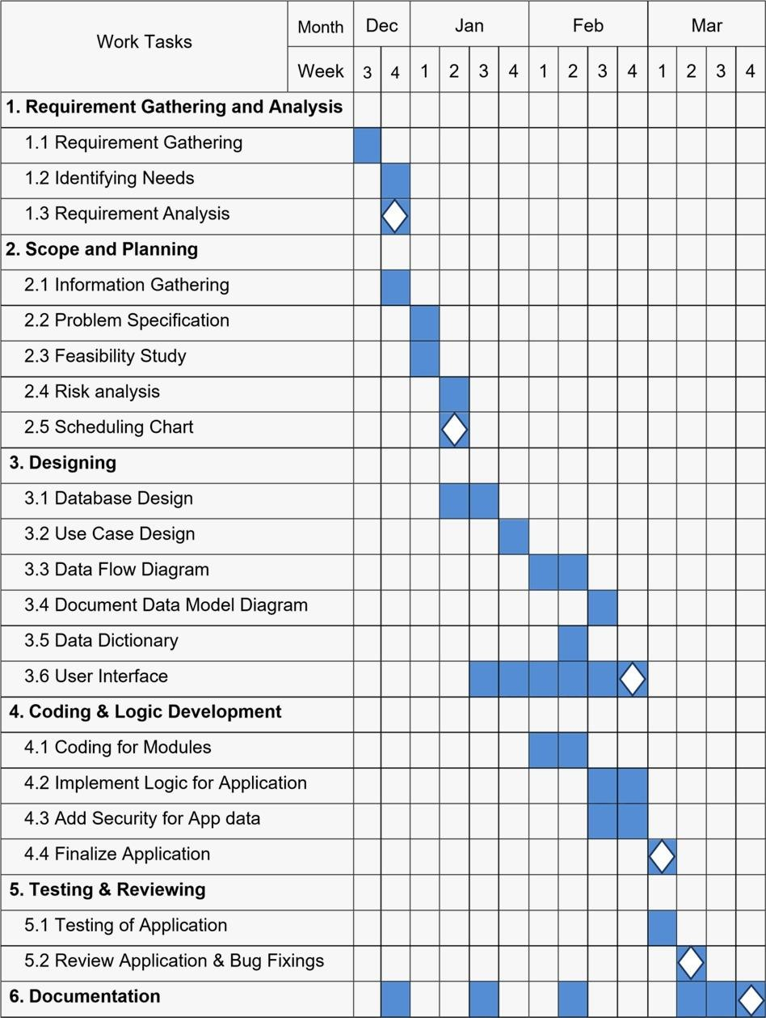



**2.4 Future Devlopment**

1. Though maximum efforts have been put in to make this report authentic in all aspects and to take all necessary presentation to ensure that the information gathered is true, some uncomfortable factors may have crept in.
2. Some of the respondents were reluctant to part with certain information on the pretext of the sensitivity of the information. Also some facts of figures were not divulged as the company policy came in the way for free revelation of the desired input.
3. An element of bias might have crept in from the side of the official interviewed. This could also have resulted in some kind of modification of the information divulged.
4. Through an attempt was make to collect information from the best possible source in the company, it was difficult to meet the top officials due to their busy schedules.
5. Most of the analysis and interpretations, made for this report, are based on secondary data obtained. This data could have some inherent mistakes and errors.
6. Finally, although due care has been taken those can be typing and compilation errors in the report itself.

The tasks specified were not well defined because nothing was mentioned regarding validations in the project. Though we gave maximum effort to check the software with different validation tests, a few of them might be present in this version.

* + Due to limited time available survey could not be undertaken for intended 20 consumers and thus had to be limited to 10.
  + Communication gaps exist between employees and management, as seniors don't share problem with subordinates resulting in violation of psychological contract.
  + Poor rewarding system(slow)
  + Poor working conditions

, 



**2.5Technology Details :**

**Hardware /Software Configuration:**

|  |  |
| --- | --- |
| Hardware Requirement: | |
| Processor | AMD Ryzen 3-3300U |
| RAM | 4.00 GB |
| HDD | -- |
| SSD | 128 GB |
| Software Used For Application Implementation: | |
| Operating System | Windows 10 Pro Single Language |
| Front End | HTML, CSS, JS |
| Code Behind | PHP |
| Back End | Microsoft SQL |
| Other Tools Used | Bootstrap |

* + **Objective:**

Hospital are the essential part of our lives, providing best medical facilities to people suffering from various ailments, which may be due to change in climatic conditions, increased work-load, emotional trauma stress etc. It is necessary for the hospitals to keep track of its day-to-day activities & records of its patients, doctors, nurses, ward boys and other staff personals that keep the hospital running smoothly & successfully.

But keeping track of all the activities and their records on paper is very cumbersome and error prone. It also is very inefficient and a time-consuming process Observing the

continuous increase in population and number of people visiting the hospital. Recording and maintaining all these records is highly unreliable, inefficient and error-prone. It is also not economically & technically feasible to maintain these records on paper.

This keeping the working of the manual system as the basis of our project. We have developed an automated version of the manual system, named as “ADMINISTRATION SUPPORT SYSTEM FOR MEDICAL INSTITUTIONS”.

The main aim of our project is to provide a paper-less hospital up to 90%. It also aims at providing low-co

st reliable automation of the existing systems. The system also provides

excellent security of data at every level of user-system interaction and also provides

robust reliable storage and backup facilities.

##### AIM:

The aim of the study to fully related with Hospital Management system.

* The Software is for the automation of Hospital Management System.
* It maintains two levels of users:-

_ Administrator Level

_ User Level

* The Software includes:-

_ Maintaining Patient details.

_ Providing Prescription, Precautions and Diet advice.

_ Providing and maintaining all kinds of tests for a patient.

_ Billing and Report generation.

The project ‘Hospital Management System’ is based on the database, object oriented and networking techniques. As there are many areas where we keep the records in database for which we are using MY SQL software which is one of the best and the easiest software to keep our information. This project uses JAVA as the front-end software which is an Object Oriented Programming and has connectivity with MY SQL. It is a web based application in which number of clients can also access with a server.



* + **FRONT END**

We have implemented **JavaScript** for all the Client side validations. Client side JavaScript is designed to reside inside HTML document & ensure they run properly. It is object based, event driven, platform independent. These are important parts of any Web application to implement Client side Validations and the invalid data is not submitted. The form is not submitted until user fills in correct data. It is extremely useful to restrict mistakes by user.

* + **BACK END**

We have used My Sql. My Sql provides efficient/effective solution for major database tech.

* + - Large database and space management.
    - Many concurrent database users.
    - High transaction processing requirement
    - High Availability
    - Industry accepted standards
    - Manageable security
    - Portability



**2.5 Technologies Details**

**Hardware/Software Configuration:**

**1.Hardware Requirement :**

**Processor :** AMD Ryzen 7 4800H With N-VIDIA RTX 3050

**RAM :** 16.00 GB

**SSD :** 512 GB

**2. Software Used For Application Implementation:**

**Operating System :** Windows 11 Professional

**Front End :** HTML,CSS,JAVASCRIPT

**Code Behind :** php

**Back End :** Mysql

**Other Tools Used :** Bootstrap, CS



**3. System Analysis and Planning**

**3.1 Existing System and its Drawbacks:**

Before the implementation of a Hospital Management System (HMS), many healthcare facilities relied on manual processes and disjointed systems, leading to several drawbacks:

**1. Paper-Based Records:** Traditional hospitals often relied on paper-based record-keeping systems, which were prone to errors, difficult to manage, and challenging to access in emergencies. This manual approach resulted in inefficiencies, delays, and increased risk of data loss or misplacement.

**2. Limited Accessibility:** In the absence of a centralized electronic system, accessing patient records and other critical information was cumbersome and time-consuming. Healthcare providers often faced challenges in retrieving data promptly, which could adversely affect patient care and decision-making.

**3. Inefficient Workflow:** Manual processes for tasks such as appointment scheduling, billing, and inventory management were labor-intensive and prone to human error. This inefficiency led to delays in service delivery, increased administrative overhead, and reduced productivity among staff members.

**4. Lack of Integration:** Without an integrated system, different departments within a hospital operated in silos, leading to communication barriers and disjointed workflows. This lack of integration hindered collaboration among healthcare professionals and compromised the continuity of patient care.

**5. Security Concerns:** Paper-based records were vulnerable to loss, theft, or unauthorized access, posing significant security risks to patient confidentiality and compliance with privacy regulations such as HIPAA. Hospitals struggled to maintain the integrity and confidentiality of patient data, risking breaches and legal repercussions.

**6. Limited Decision Support:** Manual record-keeping systems offered limited support for data analysis and reporting, making it challenging for hospital administrators to derive insights, identify trends, and make informed decisions about resource allocation, service improvement, and strategic planning.

In conclusion, the existing manual systems in hospitals were characterized by inefficiencies, lack of integration, security concerns, and limited decision support capabilities. These drawbacks underscored the urgent need for hospitals to transition to modern Hospital Management Systems to address these challenges and improve overall operational efficiency, patient care quality, and data security.

###### 3.2 Feasibility study:

* + - A feasibility study assesses the technical, operational, and economic viability of implementing the hospital management system.
    - Technical feasibility evaluates whether the necessary technology exists to support the proposed system, including hardware, software, and networking infrastructure.
    - Operational feasibility examines whether the proposed system aligns with hospital workflows, processes, and user requirements.
    - Economic feasibility assesses the cost-effectiveness of implementing the system, considering development costs, maintenance expenses, and potential return on investment.
    - The hospital management system may utilize technologies such as server-based architecture, web-based interfaces, database management systems, and programming languages such as Java, .NET, or Python.
    - The feasibility study ensures that the hospital management system meets technical requirements, operational needs, and financial constraints before proceeding with development and implementation.

**3.3 Requirement Gathering and Analysis:**

Requirement gathering and analysis for a Hospital Management System (HMS) is a critical phase that involves understanding the needs and expectations of healthcare providers, administrators, and other stakeholders. Here's an overview of the process:

**1. Identify Stakeholders:** The first step is to identify all stakeholders involved in the hospital management process, including doctors, nurses, administrative staff, patients, and regulatory authorities. Each stakeholder group will have unique requirements and perspectives that need to be considered.

**2. Conduct Interviews and Workshops:** Engage with stakeholders through interviews, focus groups, or workshops to gather insights into their specific needs, challenges, and priorities. These sessions can help uncover both functional and non-functional requirements for the HMS.

**3. Document Requirements:** Document all requirements gathered from stakeholders in a clear and organized manner. This documentation should include functional requirements (such as patient registration, appointment scheduling, billing, EMR management) as well as non-functional requirements (such as security, scalability, usability).

**4. Prioritize Requirements:** Prioritize requirements based on their importance and impact on the hospital's operations and patient care. Some requirements may be critical for the system's success, while others may be nice-to-have but not essential.

**5. Validate Requirements:** Validate requirements with stakeholders to ensure accuracy, completeness, and alignment with their needs and expectations. This may involve conducting reviews or demonstrations of the proposed system to gather feedback and make necessary adjustments.

**6. Perform Gap Analysis:** Analyze the existing hospital management processes and systems to identify any gaps or deficiencies that the new HMS should address. This helps ensure that the new system effectively meets the hospital's requirements and improves upon existing practices.

**7. Consider Regulatory Compliance:** Ensure that the HMS complies with relevant healthcare regulations and standards, such as HIPAA for patient data security and interoperability standards for seamless integration with other healthcare systems.

**8. Define Scope and Constraints:** Define the scope of the HMS project, including its functionalities, timeline, budget, and any constraints or limitations that need to be considered during development and implementation.

**9. Document Use Cases and User Stories:** Create use cases and user stories to describe how different stakeholders will interact with the HMS and accomplish their tasks. This helps ensure that the system's design and functionality align with users' workflows and preferences.

**10. Iterative Approach:** Requirements gathering and analysis is an iterative process, and it's essential to continuously engage with stakeholders throughout the development lifecycle to refine and validate requirements as needed.

By following a systematic approach to requirement gathering and analysis, healthcare organizations can ensure that their Hospital Management System effectively addresses the needs of stakeholders, improves operational efficiency, and enhances patient care delivery.



**4.Proposed System:**

**4.1 Scope:**

Requirement analysis and fact-gathering techniques play a crucial role in the development of a Hospital Management System (HMS), ensuring that the final solution meets the needs and expectations of healthcare providers, administrators, and patients. This process involves systematically gathering and analyzing requirements, understanding the workflows and challenges within the hospital environment, and identifying the key functionalities and features necessary for an effective HMS.

One common technique used in requirement analysis for an HMS is stakeholder interviews. This involves conducting structured interviews with various stakeholders, including doctors, nurses, administrative staff, IT personnel, and patients, to gather insights into their specific needs, pain points, and desired functionalities. Through these interviews, developers can gain a deeper understanding of the hospital's operations, workflows, and unique requirements, which helps in designing a tailored solution that addresses specific challenges and enhances efficiency.

**4.2 Project Modules & Functionalities Constraints:**

A hospital management system typically consists of several modules and functionalities to efficiently manage various aspects of hospital operations. Here's an outline of some common modules and functionalities along with potential constraints:

**1. Patient Management Module:**

- Functionality: Registration, admission, discharge, and transfer of patients.

- Constraints: Ensure data privacy and compliance with healthcare regulations like HIPAA (in the US) or GDPR (in the EU).

**2. Appointment Scheduling Module:**

- Functionality: Scheduling and managing appointments for patients with doctors.

- Constraints: Need to handle high volumes of appointments efficiently, consider time constraints of both patients and doctors.



**3. Doctor and Staff Management Module:**

- Functionality: Management of doctor and staff information, schedules, and roles.

- Constraints: Ensure proper credentialing and compliance with medical regulations, handle staff turnover effectively.

**4. Billing and Payment Module:**

- Functionality: Billing patients, managing insurance claims, processing payments.

- Constraints: Compliance with healthcare billing regulations and insurance requirements, accurate recording and processing of financial transactions.

**5. Inventory and Pharmacy Management Module:**

- Functionality: Managing hospital inventory, including medicines, medical supplies, and equipment.

- Constraints: Proper inventory tracking to avoid shortages or overstocking, compliance with regulations for storing and dispensing medications.

**6. Laboratory and Diagnostic Module:**

- Functionality: Managing laboratory tests, results, and diagnostic procedures.

- Constraints: Ensuring accuracy and confidentiality of test results, adherence to quality standards and regulatory requirements.

**7. Electronic Health Records (EHR) Module:**

- Functionality: Storing and managing patient health records electronically.

- Constraints: Data security and privacy, interoperability with other systems, compliance with EHR standards and regulations.

**8. Reporting and Analytics Module:**

- Functionality: Generating reports on various aspects of hospital operations, analyzing data for insights.

- Constraints: Data accuracy, ensuring reports meet regulatory requirements, protecting sensitive information.

Constraints common across these modules include:

- Integration with existing systems and workflows.

- Scalability to handle increasing data and user loads.

- User accessibility and ease of use.

- Budget and resource constraints for development and maintenance.

- Training requirements for staff members to use the system effectively.

- Security measures to protect against cyber threats and data breaches.

Developers need to carefully consider these constraints while designing and implementing each module of the hospital management system to ensure its effectiveness and compliance with regulations.

**5. Designing**

 **5.1 Data Flow Diagram**

* **Figure 1:- Context Diagram**

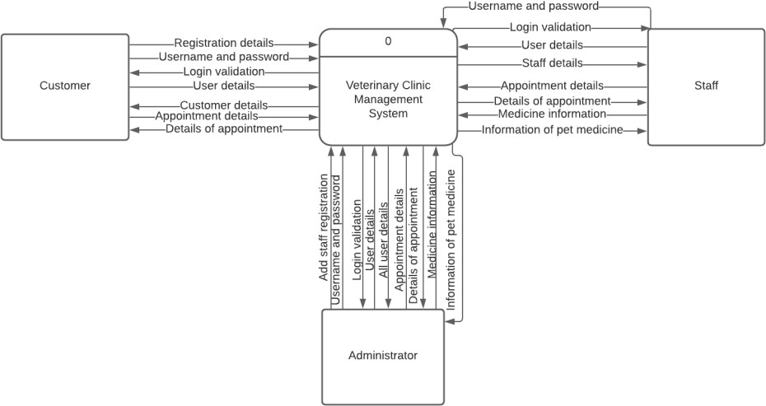

**WELLCARE**

**Hospitals**

* **Figure 2:- Data flow diagram Level 0**

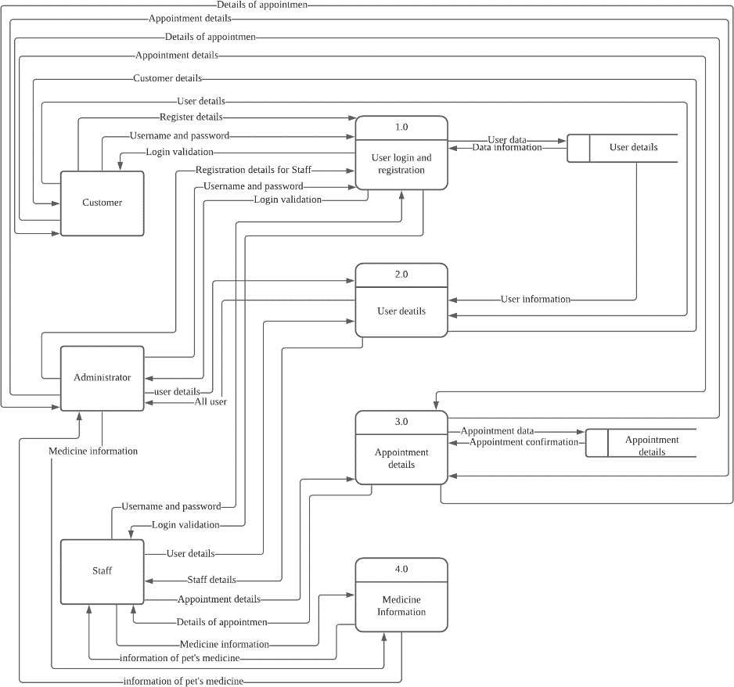



* **Figure 3 Data flow diagram level 1**

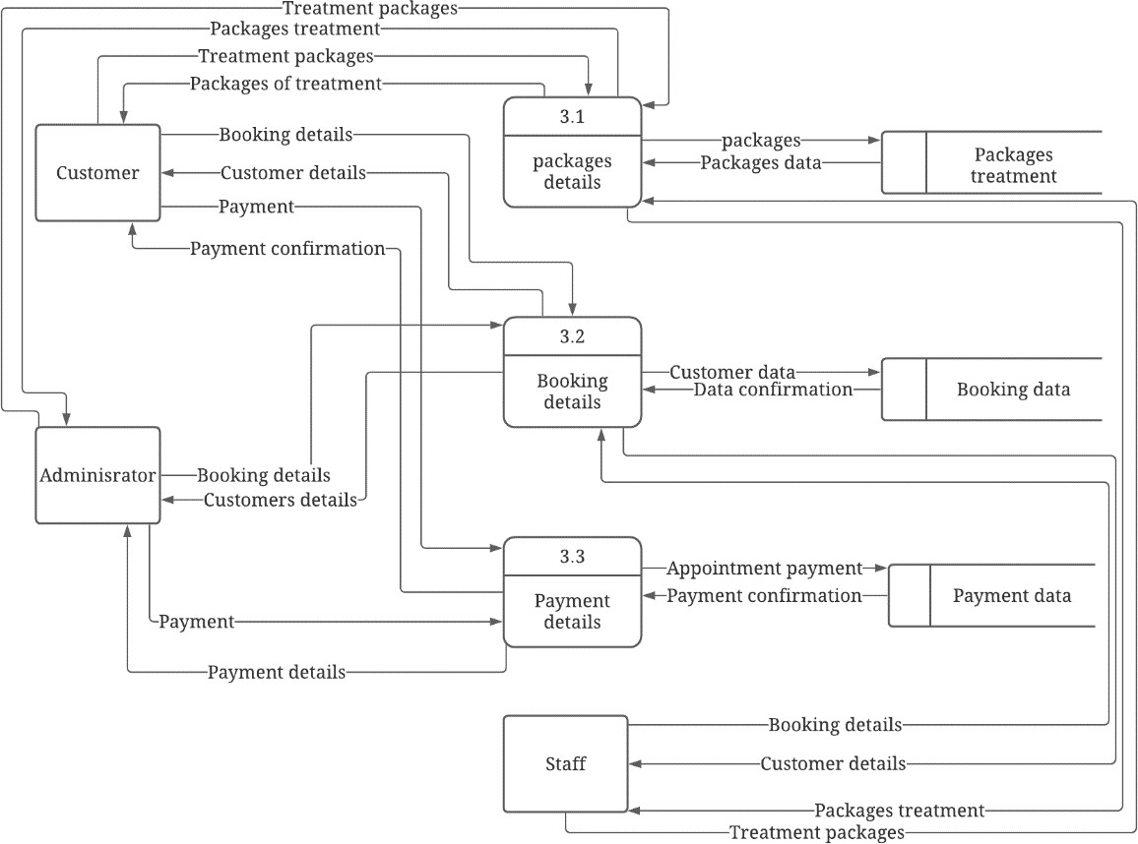



**5.2 Use Case Diagram**

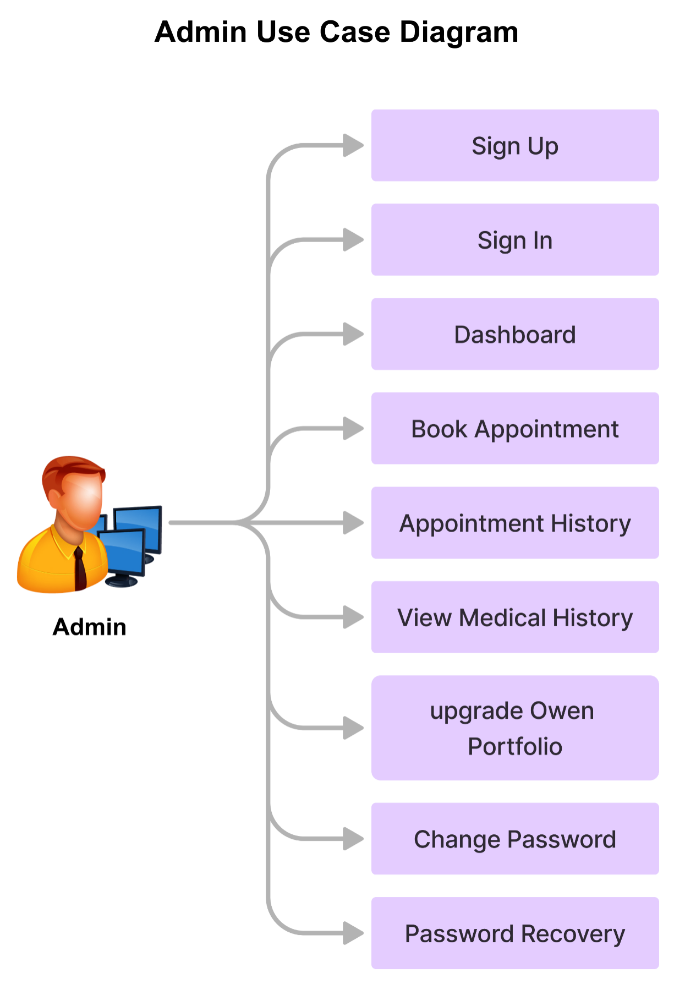

**User**

**User Use Case Diagram**



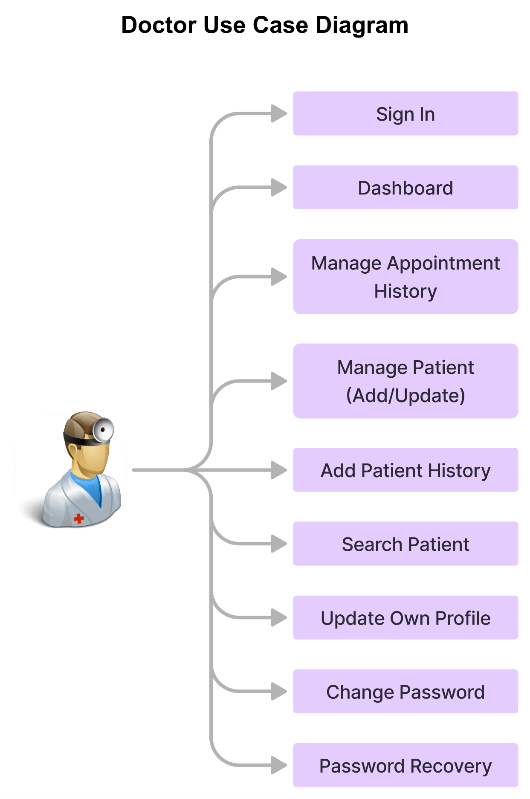

**Doctor**

**Doctor Use Case Diagram**



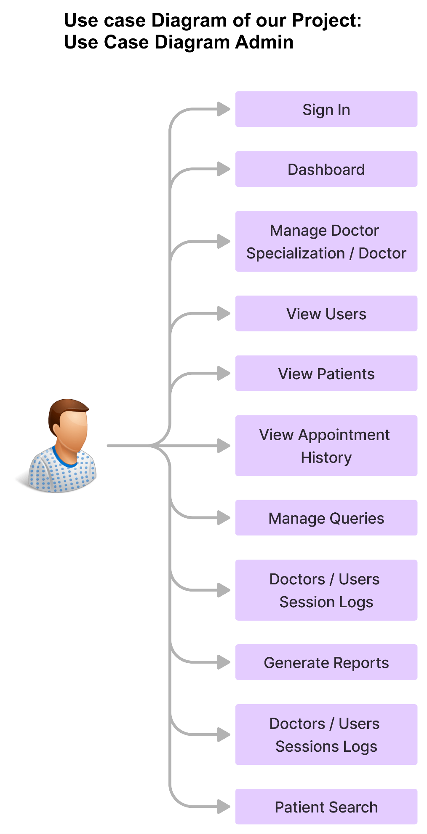



**5.3 E-R- DIAGRAM**

**Patient information**

**Admit**

**Patients**

**Hospital**

**Room**

**Doctor record**

**Doctor**

**Hospital**

**Room**

**On Line Appointment**

**Hospital**

**Patient**

**Discharge**



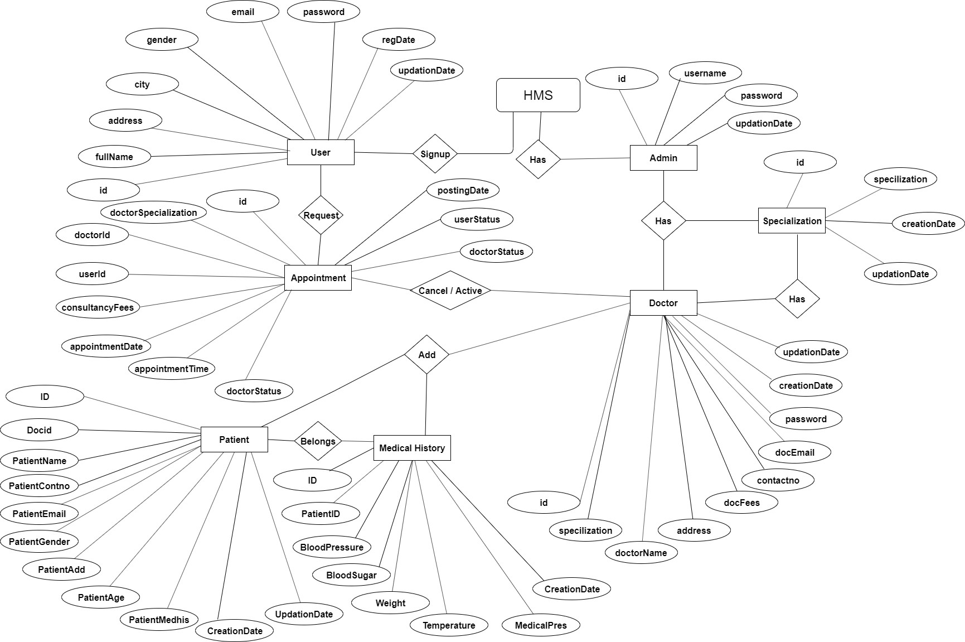



**SYSTEM DEVELOPMENT LIFE CYCLE**

User Revised Requirement Requirement Specification

Requirement Determination

Decision to

Design Information System

Initial Requirement Investigation

Feasibil ity Analysi

Test Plan

Feasibility Study

.

Logical System Design

System Implementation

System Design

Functional Spec.

System Specifica tion Analysis

System Configuration

Data

Physical

Requirement

Schedule Budget

System Evaluation

Hardware Study

System Modification Improved System Maintenance



**Context Level DFD**

*Medical Advice*

*Patient Appointment*

*PG*

*Programmer*

*Patient Status*

*Bill Payment*

*Carrier & Job Hospital*

***HOSPITAL MANAGEMENT SYSTEM***



**DFD for Medical Advice**

*1. Read the Data from*

*patient*

*2. Search for disease from Knowledge*

*3. Copy Selected Record*

*Output Unit*

*Data base*

*Patient*



**DFD for patient Appointment**

*1. Read patient request*

*2. Search from Doctor Data base*

*3. Give the Time and Number*

*Output UNIT*

*Database*

*USER*



**DFD for Patient Search**

*1. Read the Data from*

*patient*

*2. Search the patient in patient-ID*

*3. Copy Selected Record*

*Output Unit*

*Database*

*Patient*



**DFD for PG Course**

*1. Accept Data for*

*specializing*

*2. Search for Seat*

*Availability*

*3. Display the Admission*

*status for PG Course*

*Output Unit*

*Database*

*Doctor*



**DFD For Bill Payment**

*1. Read the Patient Data & Treatment*

*2. Generate the bill*

*Print Bill*

*Patient*

*Output Device*

*Accountant*

*DATABASE*



**DFD For Online Searching For Patient**

*Read Patient Name*

*Data base*

*Patient Data*

*CRT*

*User*



**DFD For Searching a Doctors**

*Bas*

*e*

*Read the Data of Doctor &*

*Specialisation*

*Doctor’s With Specialties*

*CRT*

*Data*

*User*



**DFD Online Medical Advice**

*Read Patient Data and Disease*

*Data Base*

*Display the Remedies & Treatments*

*Output*

*User*



**DFD For Login Of User**

*Read User Id & Password*

*Data Base*

*Authenticate User & Login*

*Output*

*User*



**Bed Details**

**PATIENT**

1 Admitted

#### FILE

1.1 Display Form

Update Table

1.2 Get Details

Process

Patient Document

1.4

Update

1.3

assign bed



## DATA FLOW DIAGRAM ADMISSION OF A NEW PATIENT

**PATIENT**

1 Admitted

FILE

1.1 Display Form

Process

Update Table

1.2 Get Details

Patient Details

1.4

Update

1.3

Assigning a Doctor



## DATA FLOW DIAGRAM RECORD MODIFICATION

**USER**

1

Read the patient

Scan Record

2

Show the Details of Record

FILE

Processing

Update

3

Modify Details of Record

## DATA FLOW DIAGRAM DISCHARGE OF PATIENT

**PATIENT**

1 Scan the patient name

FILE

1.1 Display Form

Update Table

Process



Patient Details

1.4

Update

1.2 Get Details



## DATA FLOW DIAGRAM LISTING OF PATIENTS

Scan Record

1

Read the Bed number

2 Select Record from Database

3 Copy Selected Record

Processing

6 Copy Selected Record

4

Compute Total

Processing

Output

5 Select Records

7

Compute Bill

8

Generate Total List

Final Output

To Screen/Printer

**OUTPUT UNIT**

**PATIENT**

FILE



**DATA FLOW DIAGRAM LIST OF ALL RECORDS**

Scan All Record

1

Read the Request

2 Select Record from File

Processing

3 Copy Selected Record

7 Copy Selected Record

4

Compute Total

5

Select Record

Output

Processing

7

Compute bill

8 Generate Total List

Final Output

To Screen/Printer

**OUTPUT UNIT**

**MANAG EMENT**

FILE



**5.4 Entity Relational Diagram / Class Diagram**:

A Class is a category or group of things that has similar attributes and common behavior. A Rectangle is the icon that represents the class it is divided into three areas. The upper most area contains the name, the middle; area contains the attributes and the lowest areas show the operations. Class diagrams provides the representation that developers work from. Class diagrams help on the analysis side, too.

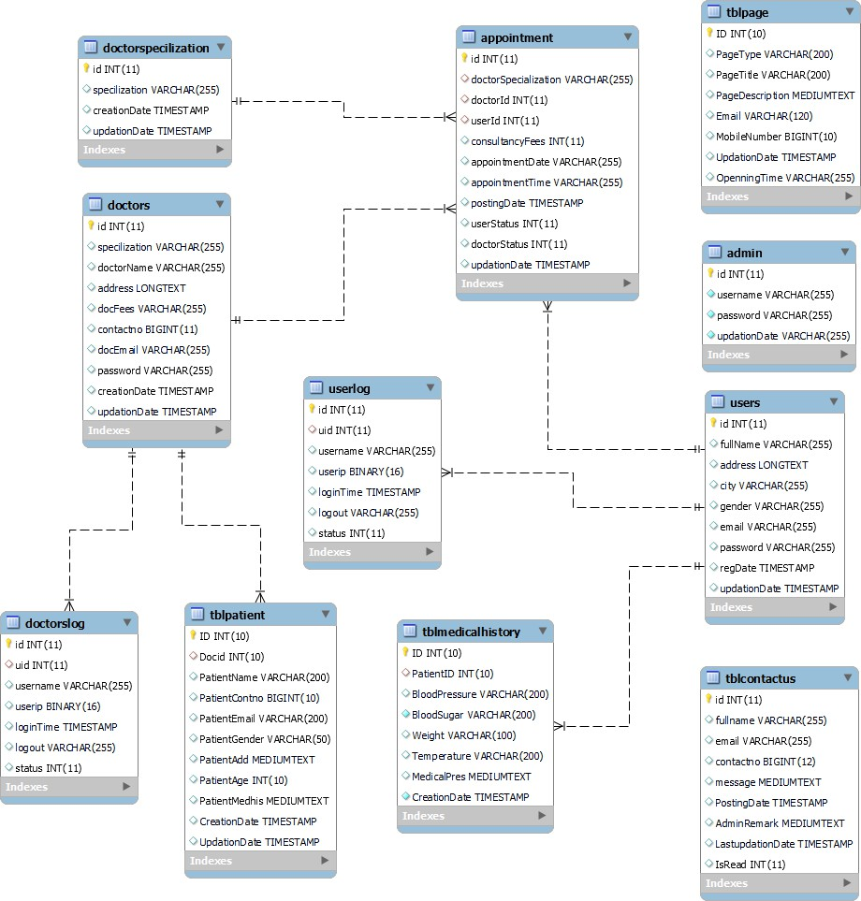



A **Deployment Diagram** shows the configuration of run-time processing nodes and the components that live on them. Deployment diagrams address the static deployment view of architecture. They are related to component diagrams in that a node typically encloses one or more components.

**Database Server**

**Hospital Local Server**

**Printer**

**desktop Client**

###### Statechart Diagrams:

The state diagram shows the states of an object and represents activities as arrows connecting the states. The Activity Diagram highlights the activities. Each activity is represented by a rounded rectangle-narrower and more oval-shaped than the state icon. An arrow represents the transition from the one activity to the next. The activity diagram has a starting point represented by filled-in circle, and an end point represented by bulls eye.





Enter Hospital

Takes Appointment

Undergo Diagnosis

not cured

Takes Treatment

undergo labtests and buy medicines

gets cured



**6. System Design**

**6.1 Database Design**

* **Users table:-**

|  |  |  |
| --- | --- | --- |
| Field | Type | Constraint |
| Name | Char (30) | Not Null |
| Emp Id | Char (30) | Primary Key |
| Email Id | Char (30) | Not Null |
| Password | Char (30) | Not Null |

* **Admin:-**

|  |  |  |
| --- | --- | --- |
| Field | Type | Constraint |
| Username | Char (30) | Not Null |
| Password | Char (30) | Not Null |

* **Pateint table:-**

|  |  |  |
| --- | --- | --- |
| Field | Type | Constraint |
| Card_no | Char (30) | Primary key |
| Name | Char (30) | Not Null |
| Gender | Char (30) | Not Null |
| Age | Numeric | Not Null |
| Address | Char (60) | Not Null |
| Phone | Numeric | Not null |
| Department | Char (60) | Not Null |
| Doctor_name | Char (30) | Not null |



* **Doctor Master:-**

|  |  |  |
| --- | --- | --- |
| Field | Type | Constraint |
| Dr_code | Char (30) | Not null |
| Dr_name | Char (30) | Not null |
| Gender | Char (30) | Not null |
| Date_of_birth | Date | Not null |
| Address | Char (30) | Not null |
| Date_of_join | Date | Not null |

* **Test_master:-**

|  |  |  |
| --- | --- | --- |
| Field | Type | Constraint |
| Test_code | Char(30) | Not null |
| Test_test | Char(30) | Not null |
| Rate_per_test | Char (30) | Not null |

* **Feedback:-**

|  |  |  |
| --- | --- | --- |
| Field | Type | Constraint |
| Name | Char (30) | Not Null |
| Email Id | Char (30) | Not Null |
| Phone | Char (30) | Not Null |
| Comment | Char (60) | Not null |



**6.2 Input / Output Design**

* **Home page:**

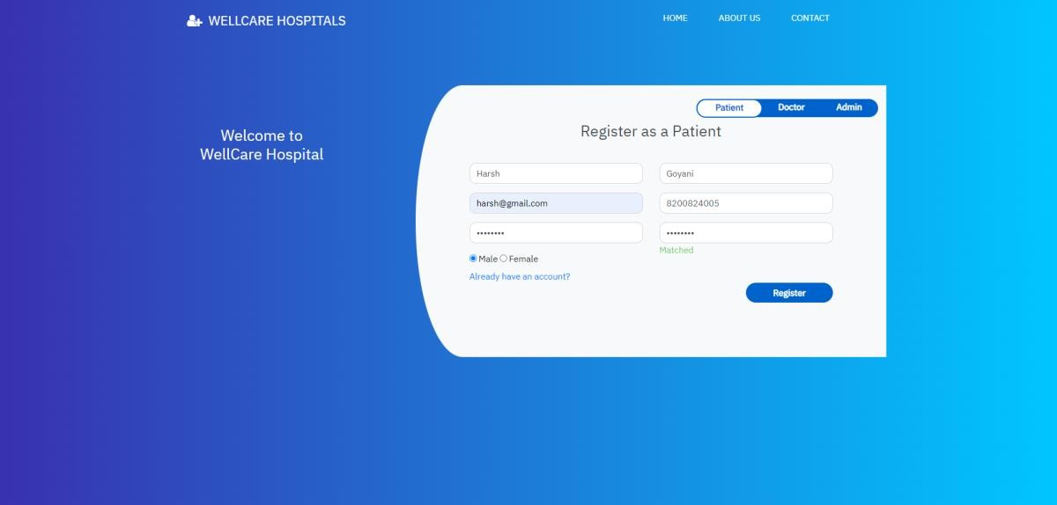

* **Patient Register:**

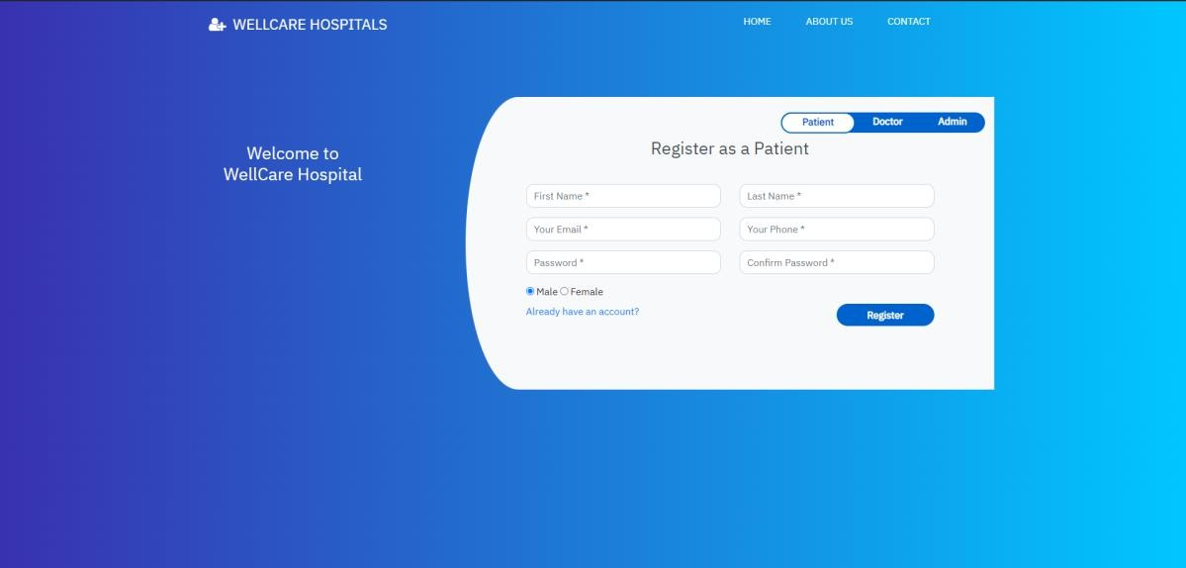



* **Patient Login:**
* 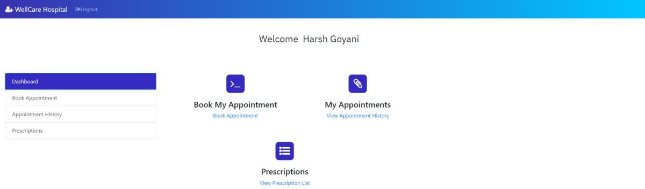**Patient Dashboard:**



* **Book Appointment:**

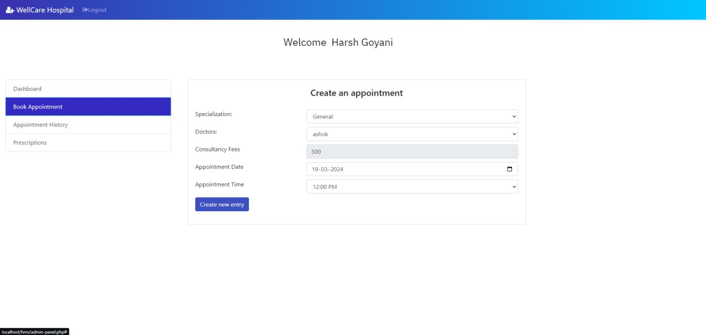

* 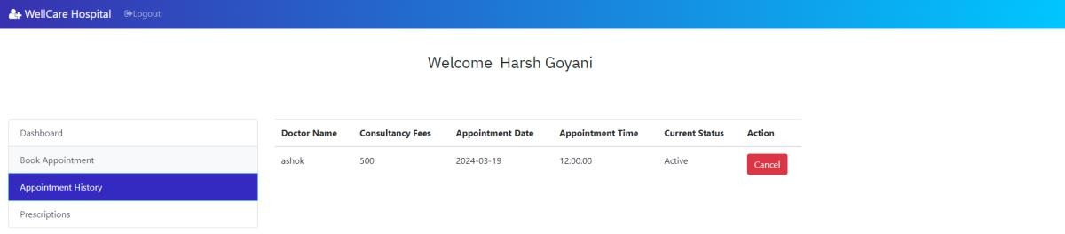**Appointment history**



* 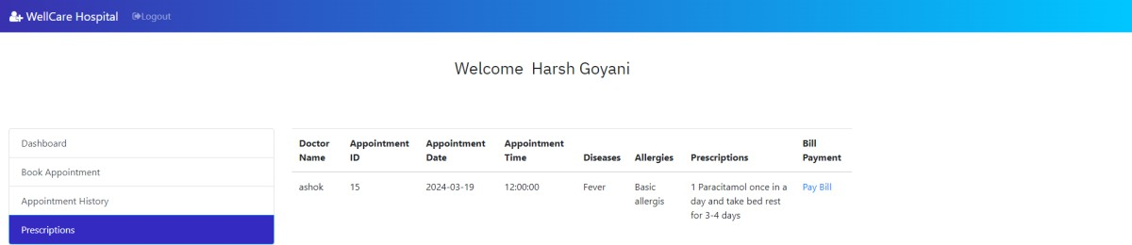**Prescriptions:**
* **Pay Bill:**



* 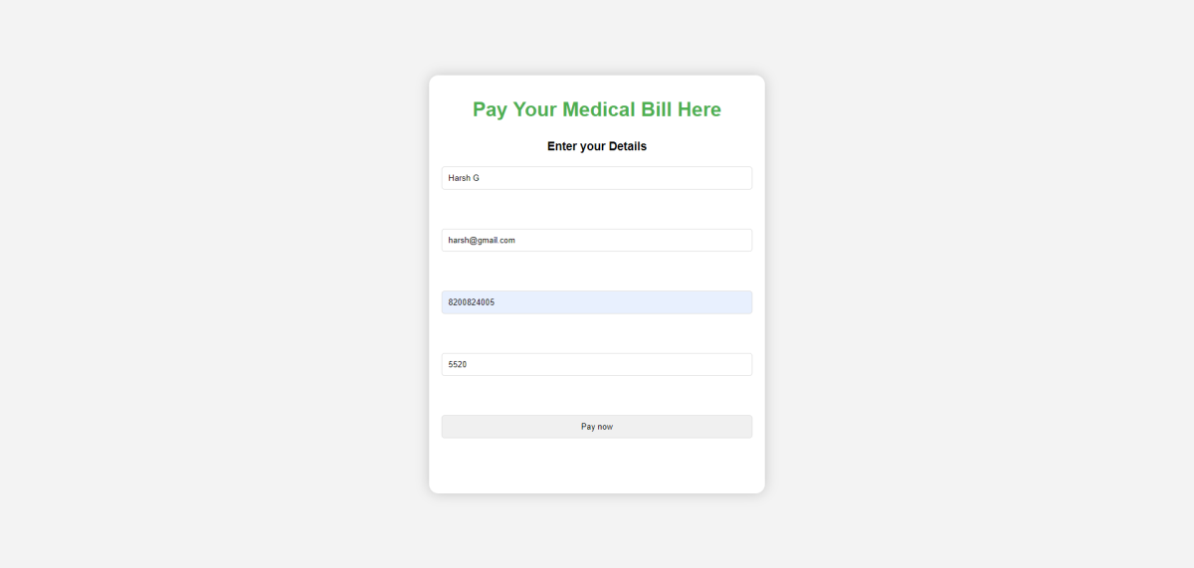**Bill payment details form:**
* 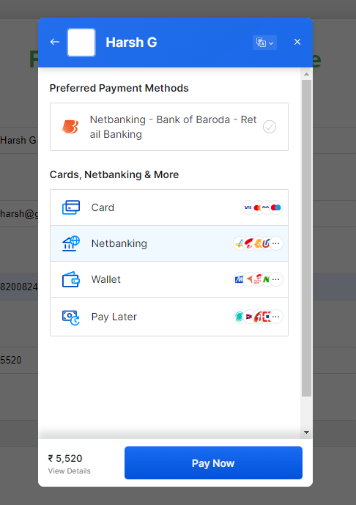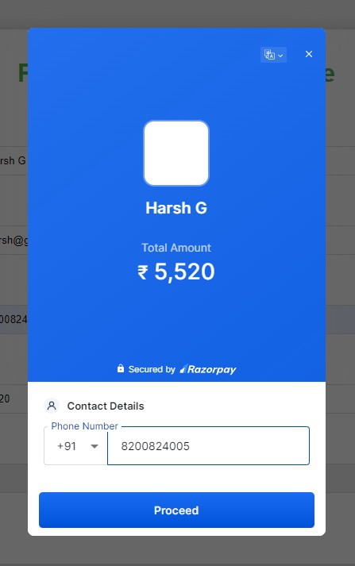**Bill Payment Methods:**



* **Enter your Details form:**

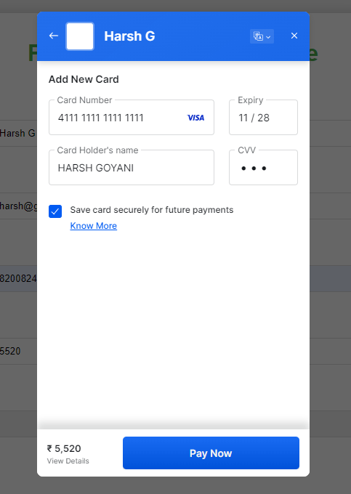

* 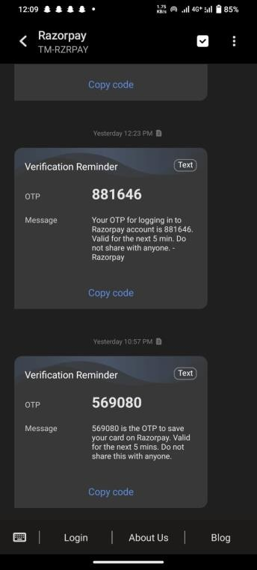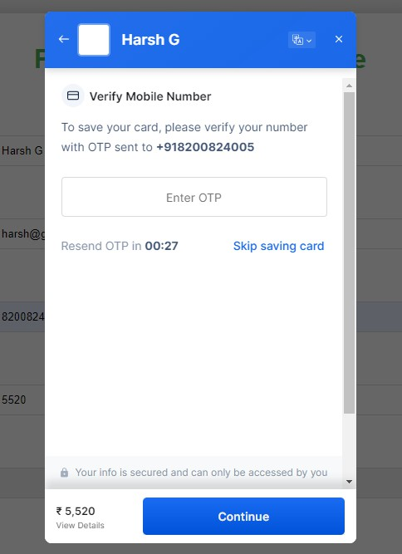**Get OTP on your Register mobile number:**



* **Final payment page:**

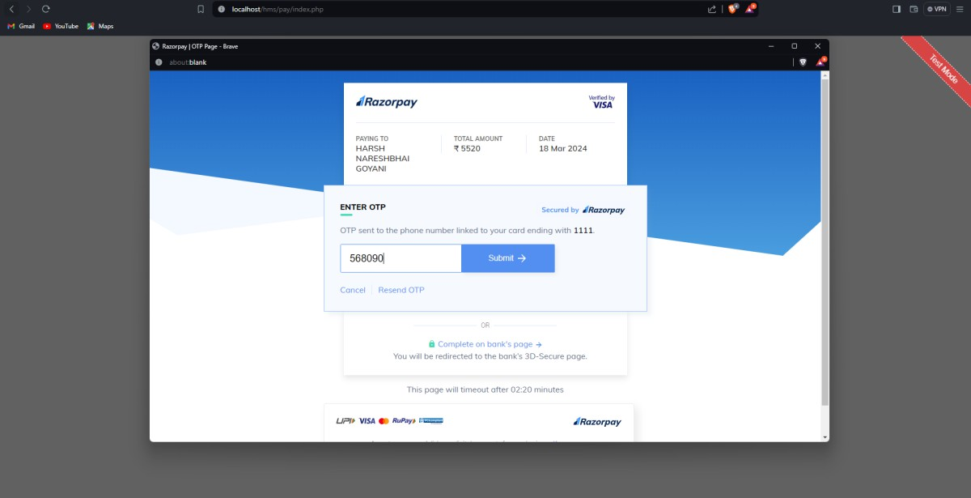

* **Payment successful page:**

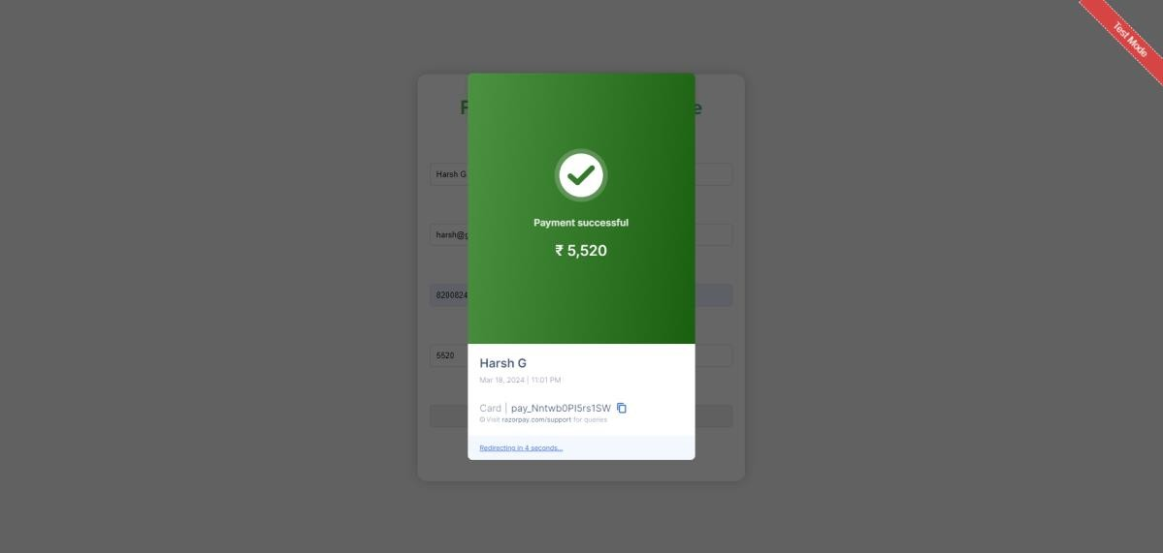



* **Success Page:**

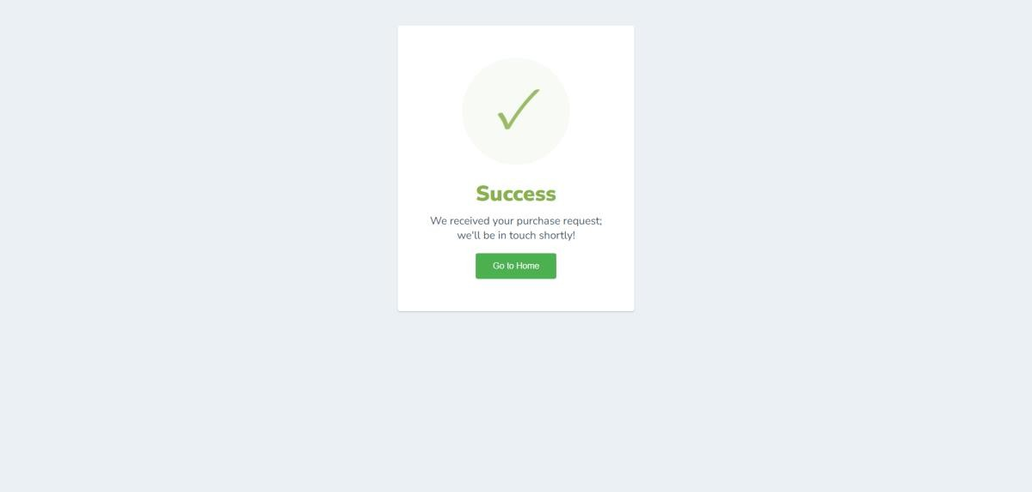

* **Sales report page:**

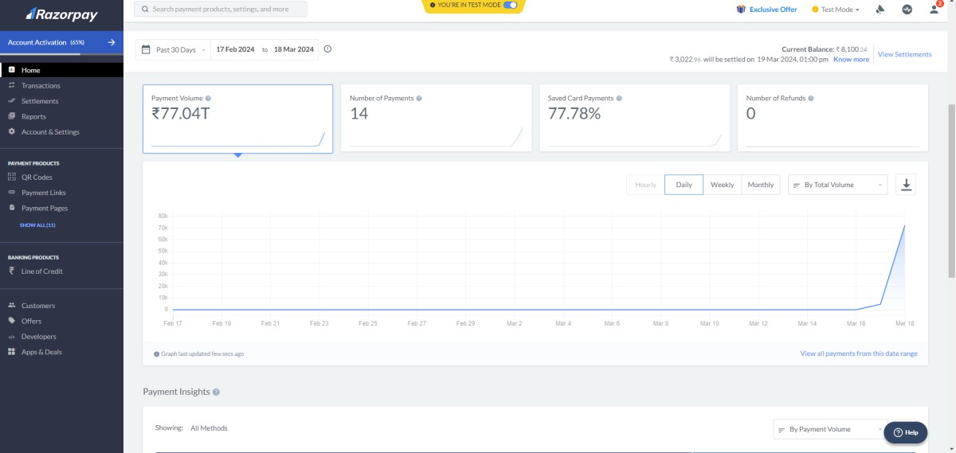



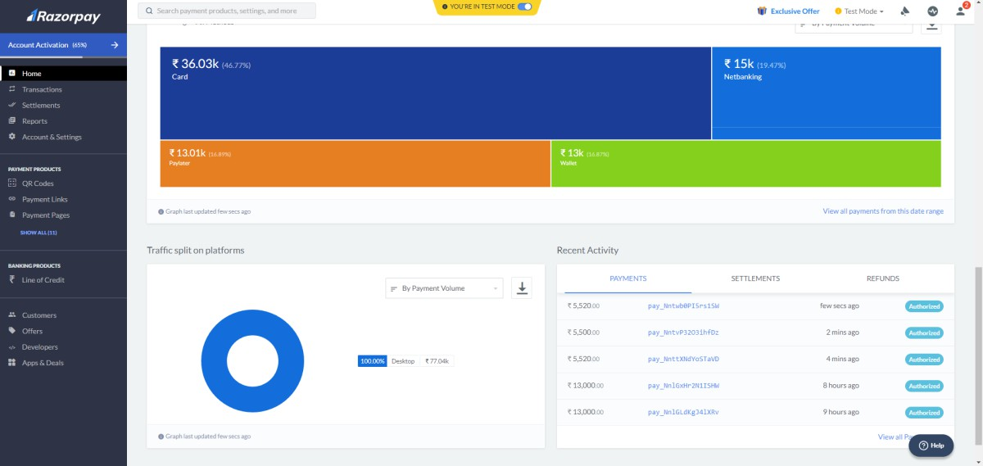

* 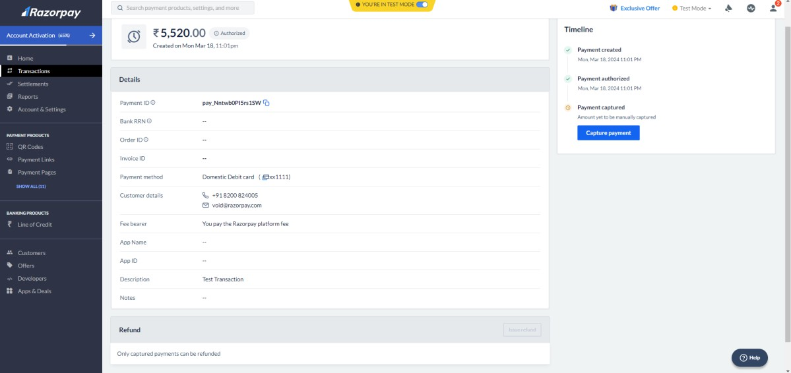**Billing Details:**



* **Recent payments:**

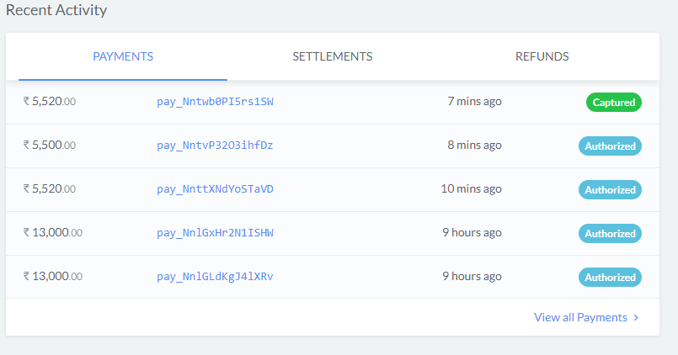



* **Doctor login page:**

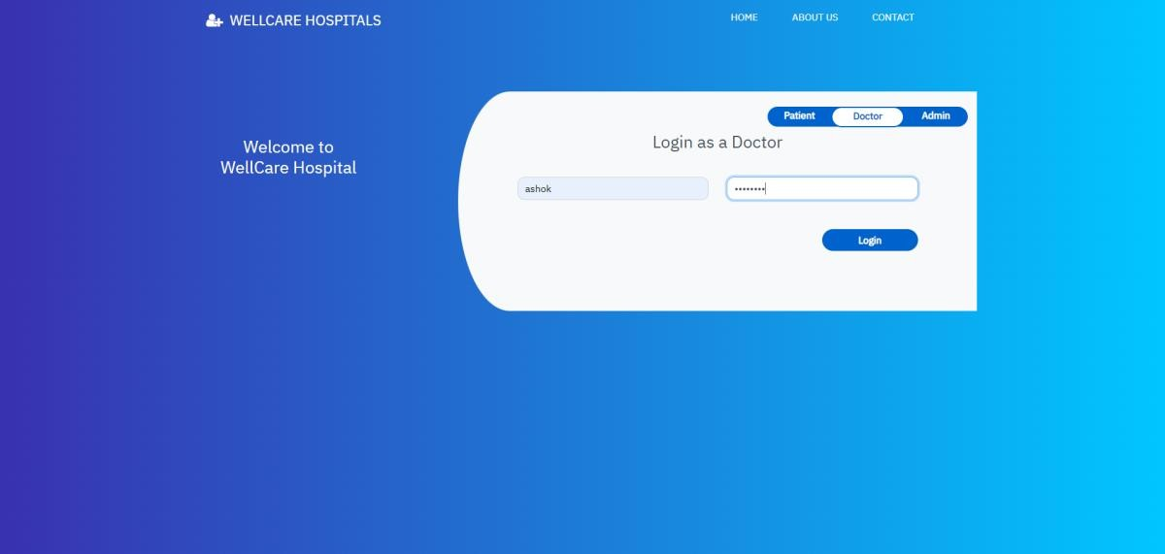

* **Doctor Dashboard:**

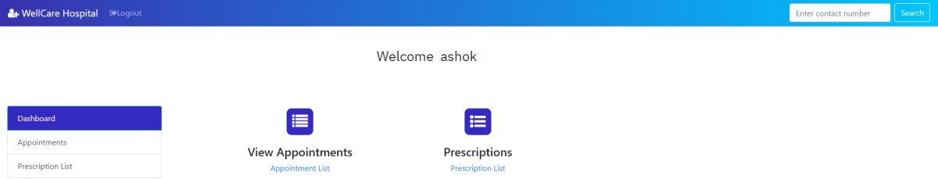



* **Doctor Appointment List:**

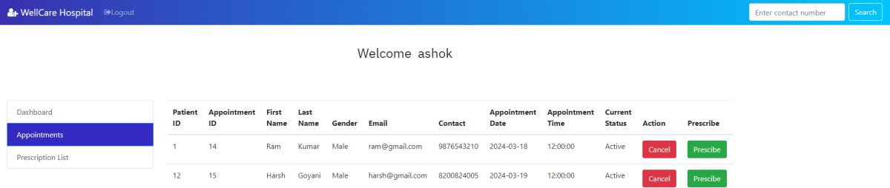

* **Prescribe the medicine:**

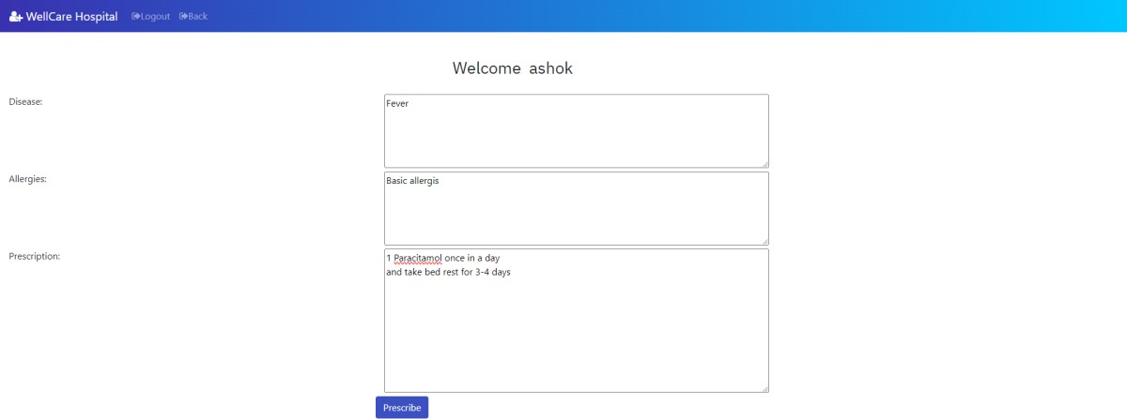



* **Prescription list:**

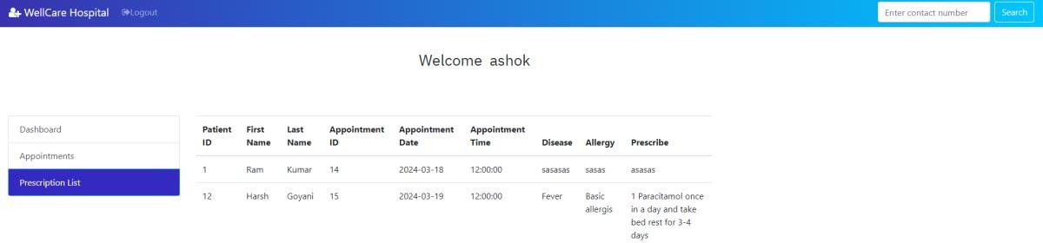

* **Prescriptions search results:**

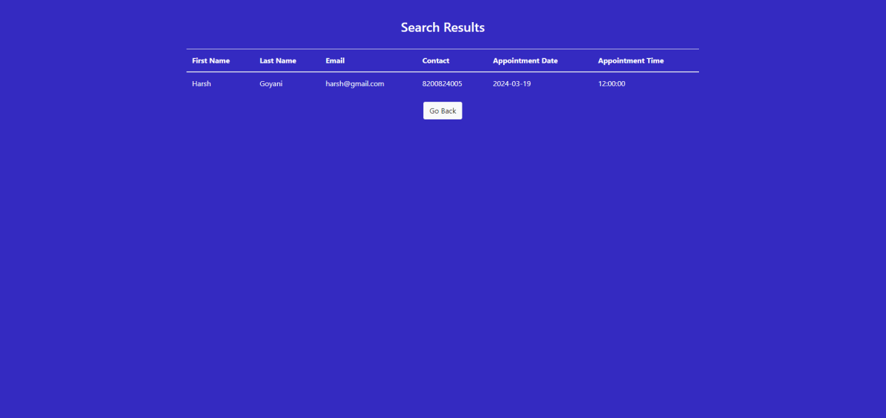



* **Admin login:**

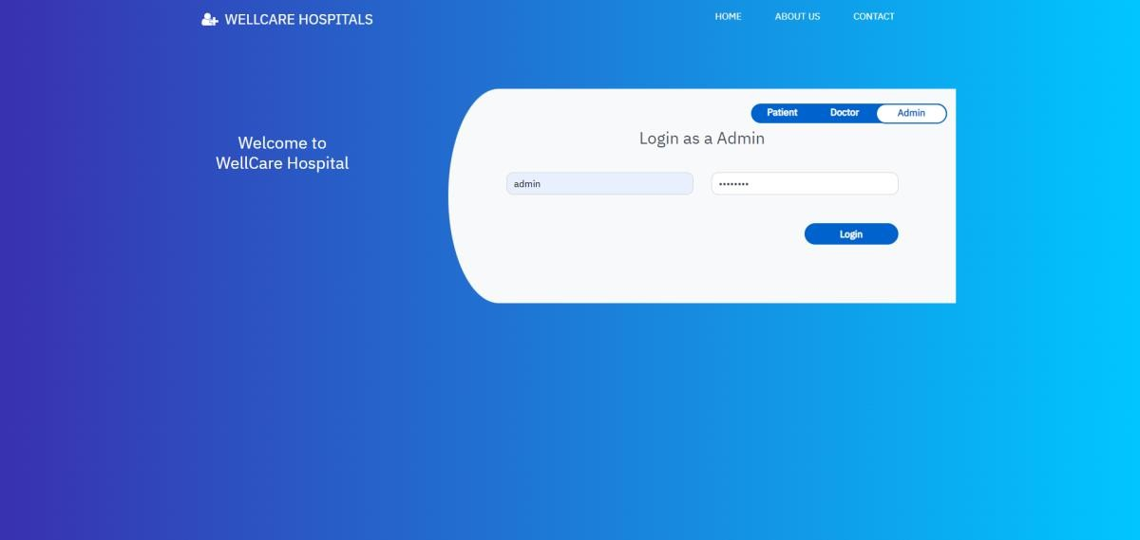

* **Admin dashboard:**

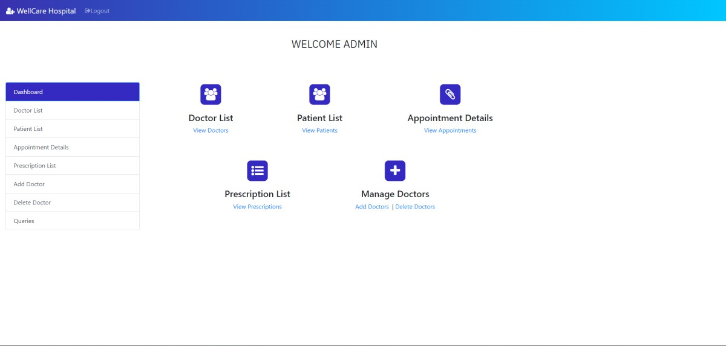



* **Doctor list:**

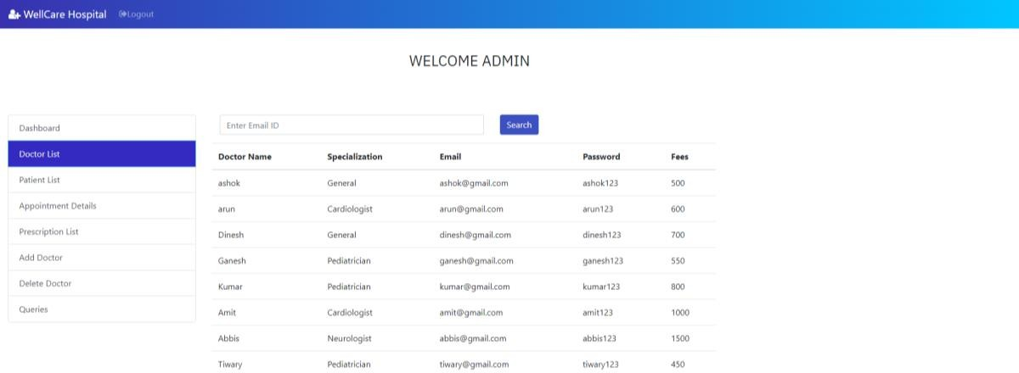

* **Patient list:**

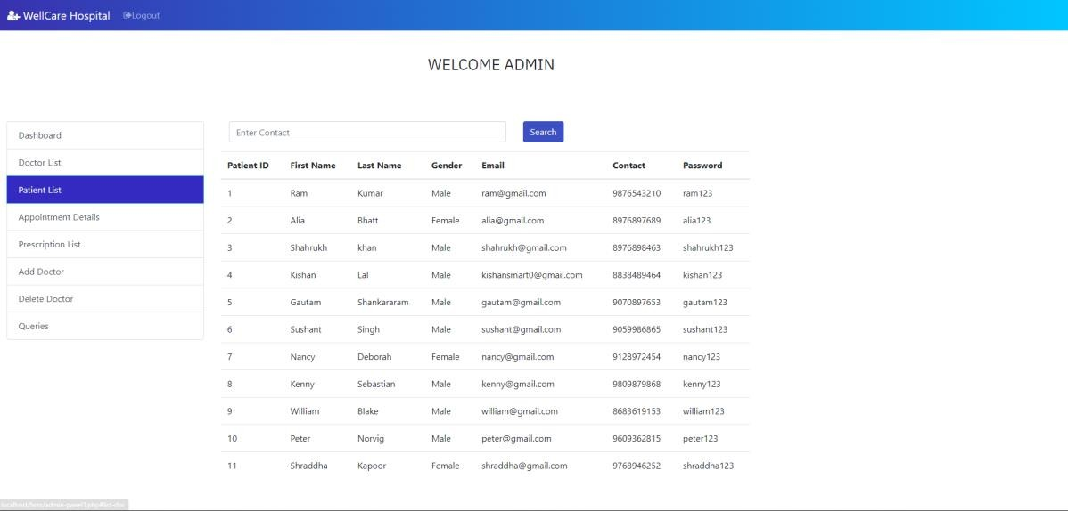



* **Appointment details:**

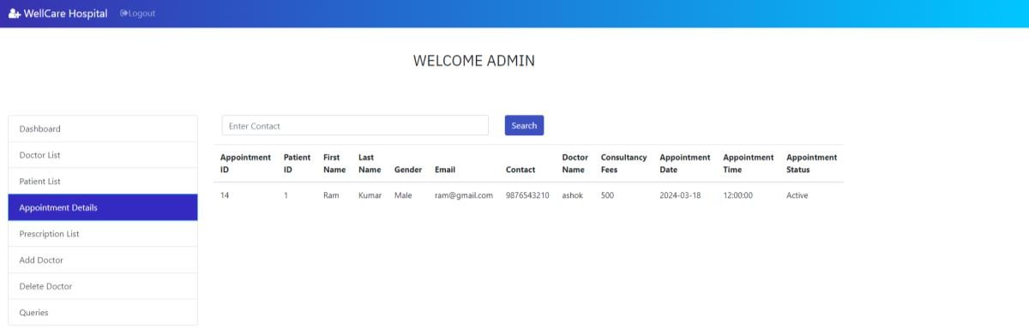

* **Prescription list:**

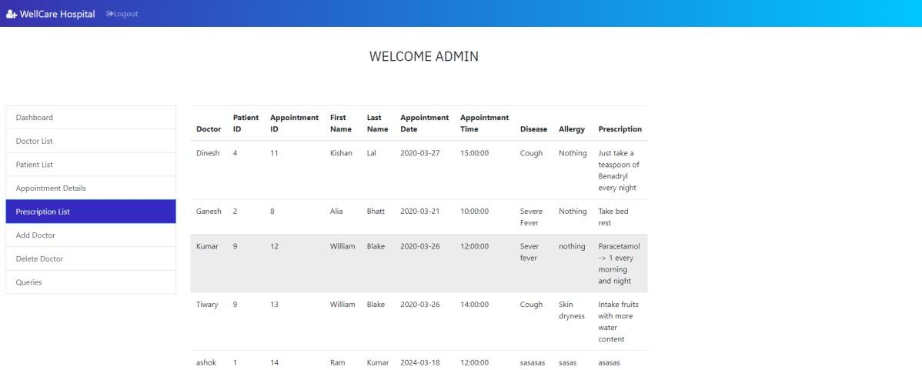



* **Add doctor:**

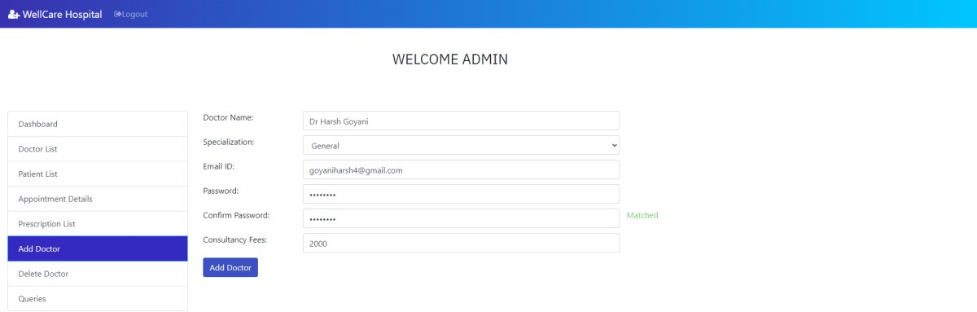

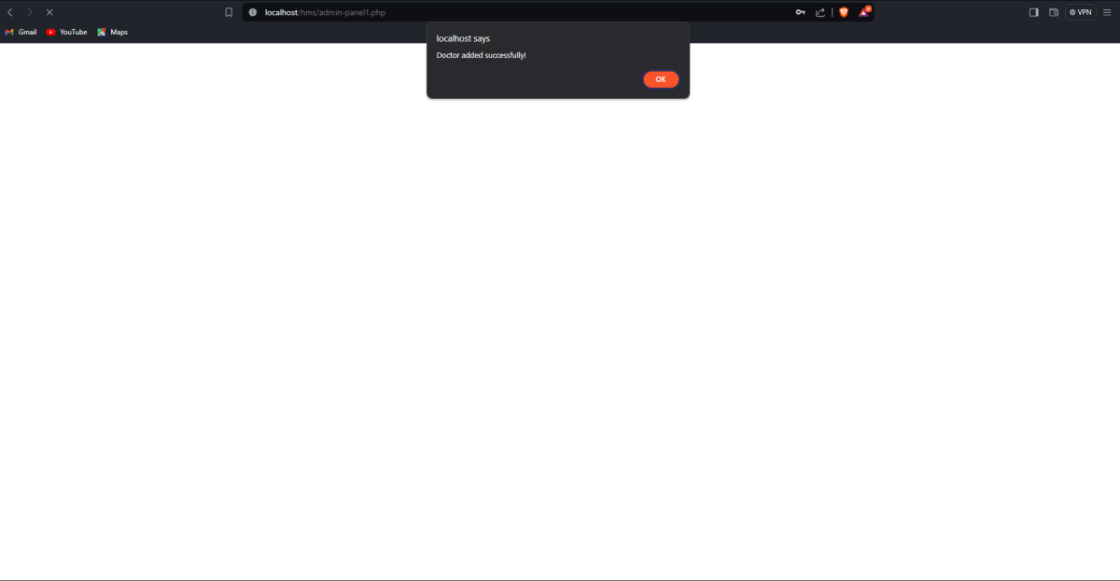



* **Delete Doctor:**

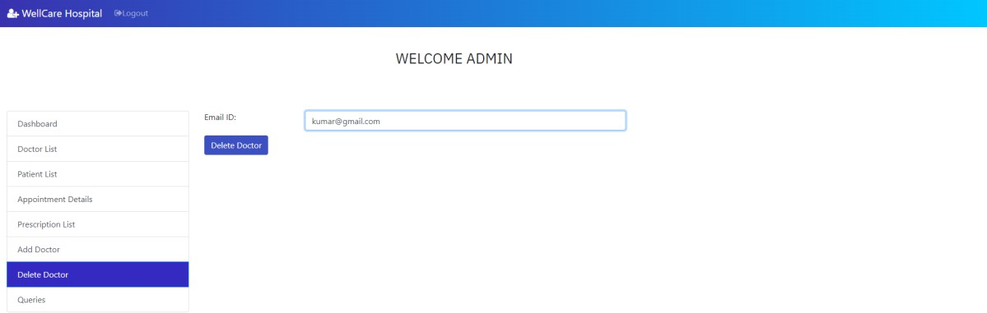

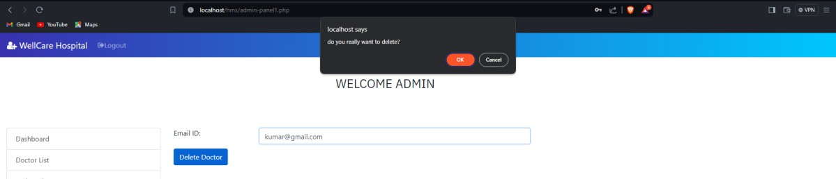

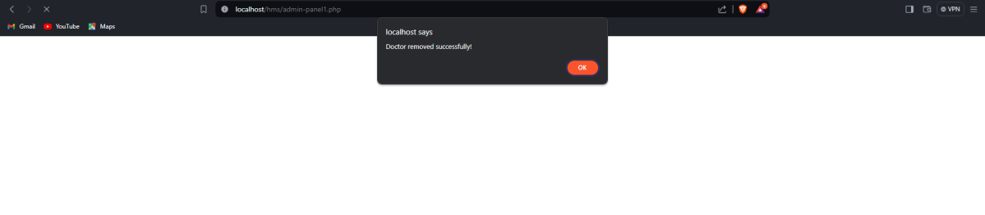



* 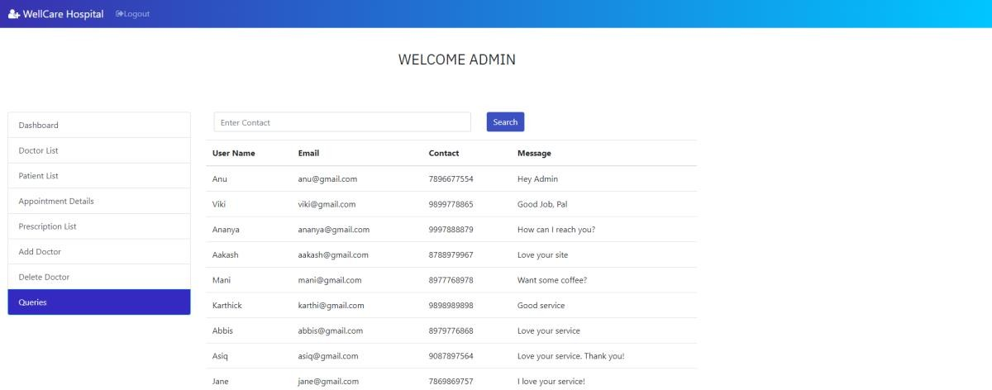**Queries:**
* **Search Queries:**

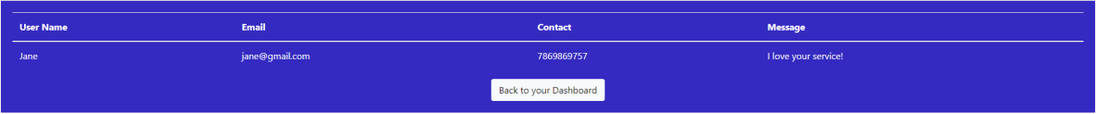



* 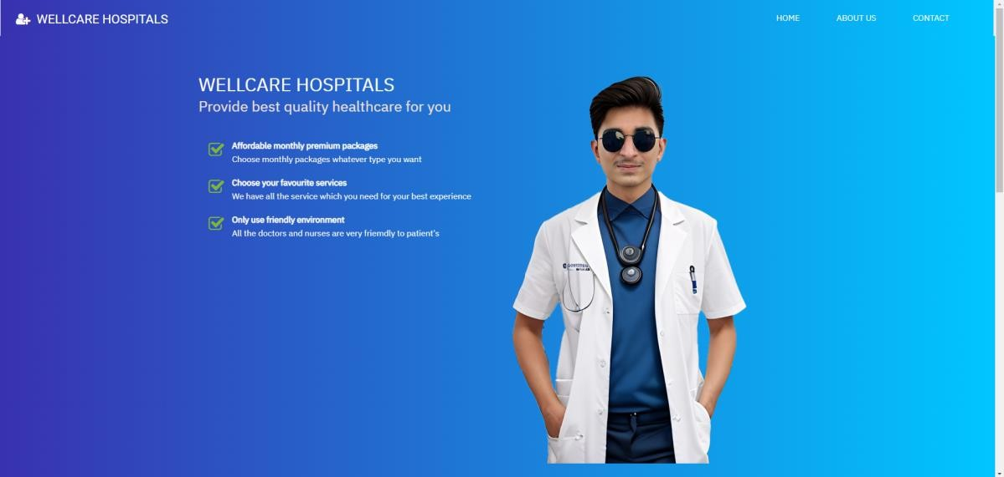**About us:**

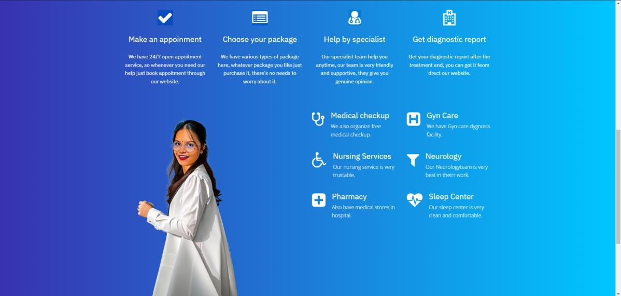

70



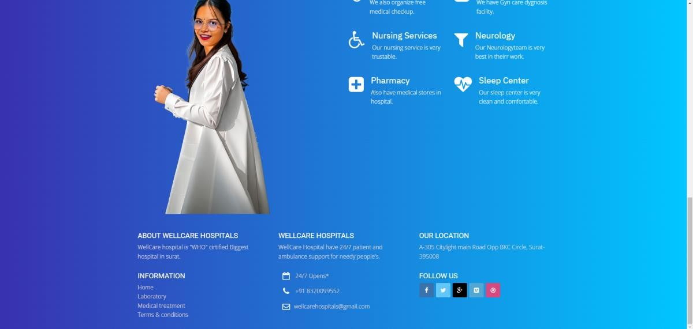

* **Contact Us:**

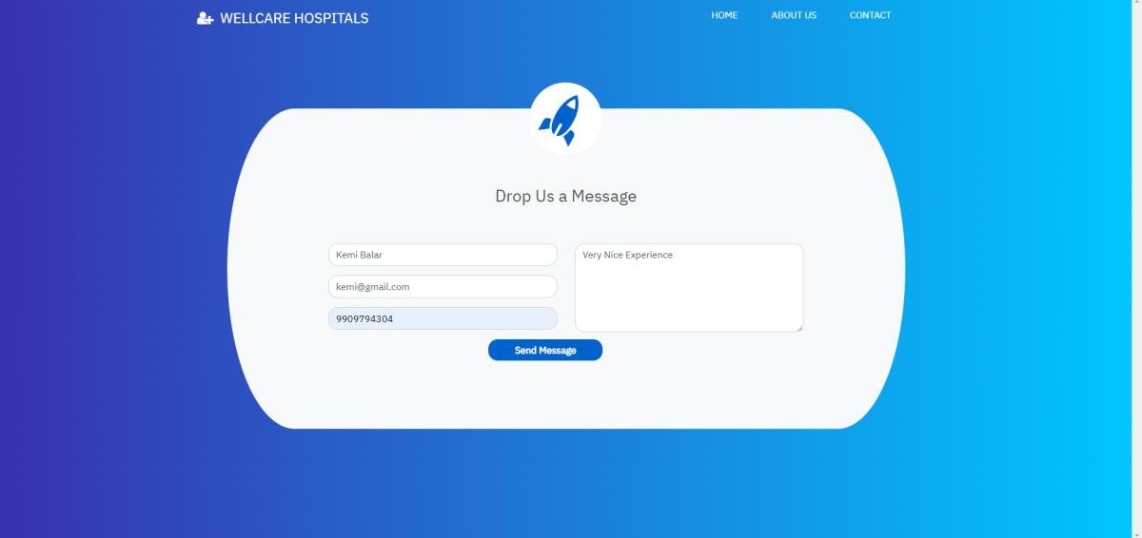



**7. Software Testing**

**7.1 Unit Testing:**

**Test case for Admin – Login**

|  |  |  |  |  |
| --- | --- | --- | --- | --- |
| Test Id | Test Field | Step Execute | Executed Result | Actual Result |
| 1 | Username | Empty Or Wrong | Msg. ‘Email field  is required | As Expected |
| 2 | Password | Empty | Msg. ‘Password  field is required’ | As Expected |

**Test case for Admin- User**

|  |  |  |  |  |
| --- | --- | --- | --- | --- |
| Test Id | Test Field | Step Execute | Executed Result | Actual Result |
| 1 | Username | Empty Or Wrong | Msg. ‘Full Name is  required’ | As Expected |
| 2 | Password | Empty Or Wrong | Msg. ‘Password is  required’ | As Expected |
| 3 | Confirm Password | Empty Or Wrong | Msg. ‘Address is  required’ | As Expected |

**Test case for Admin – Doctor**

|  |  |  |  |  |
| --- | --- | --- | --- | --- |
| Test Id | Test Field | Step Execute | Executed Result | Actual Result |
| 1 | Doctor Name | Empty Or Invalid Or  Already Exists | Msg. ‘Doctor Name is required’ | As Expected |
| 2 | Type | Empty Or Wrong | Msg. ‘Type is  required’ | As Expected |
| 3 | Email | Empty Or Wrong | Msg. ‘Email is  required’ | As Expected |
| 4 | Password | Empty Or Wrong | Msg. ‘Password is  required’ | As Expected |
| 5 | Confirm Password | Empty Or Wrong | Msg. ‘Password is  required’ | As Expected |
| 6 | Fees | Empty Or Wrong | Msg. ‘Fees is  required’ | As Expected |



1. **Test case for Doctor**

|  |  |  |  |  |
| --- | --- | --- | --- | --- |
| Test Id | Test Field | Step Execute | Executed Result | Actual Result |
| 1 | Doctor ID | Empty Or  Invalid Or Already Exists | Msg. ‘Doctor ID is  required’ | As Expected |
| 2 | Name | Empty Or Wrong | Msg. ‘Name is required’ | As Expected |
| 3 | Type | Empty Or Wrong | Msg. ‘Type is  required’ | As Expected |
| 4 | Email | Empty Or Wrong | Msg. ‘Email is required’ | As Expected |
| 5 | Password | Empty Or Wrong | Msg. ‘Password is  required’ | As Expected |
| 6 | Fees | Empty Or Wrong | Msg. ‘Fees is  required’ | As Expected |

1. **User Testing Test case for User – Login form**

|  |  |  |  |  |
| --- | --- | --- | --- | --- |
| Test Id | Test Field | Step Execute | Executed Result | Actual Result |
| 1 | User Fname | Empty Or  Invalid Or Already Exists | Msg.’User Fname  is required’ | As Expected |
| 2 | Last Name | Empty Or Wrong | Msg. ‘Lname is  required’ | As Expected |
| 3 | Email | Empty Or Wrong | Msg. ‘Email is  required’ | As Expected |
| 4 | Contact Number | Empty Or Wrong | Msg. ‘Contact Number is required’ | As Expected |
| 5 | Password | Empty Or Wrong | Msg. ‘Password is  required’ | As Expected |
| 6 | Confirm Password | Empty Or Wrong | Msg. ‘Password not matched is  required’ | As Expected |



###### 7.2 Navigation Testing : Admin

|  |  |  |
| --- | --- | --- |
| Link | Expected Page | Result Of page |
| Admin Login | Admin Login page | Admin Login page |
| Admin Dashboard | Admin Dashboard page | Admin Dashboard page |
| Inquiries | Admin Inquiries page | Admin Inquiries page |
| Doctors | Admin Doctors page | Admin Doctors page |
| Add/Delete Doctors | Admin Add/Delete Doctors page | Admin Add/Delete Doctors page |
| Users | Admin Users page | Admin Users page |
| Admin Logout | Admin Logout page | Admin Logout page |

**Doctor**

|  |  |  |
| --- | --- | --- |
| Link | Expected Page | Result Of page |
| Doctor Login | Doctor Login page | Operator Login page |
| Doctor Dashboard | Doctor Dashboard page | Operator Dashboard page |
| Patient Appointment | Patient Appointment page | Patient Appointment page |
| Prescribe medicine | Doctor Prescribe medicine page | Doctor Prescribe medicine page |
| Admin Logout | Doctor Logout page | Doctor Logout page |

**User**

|  |  |  |
| --- | --- | --- |
| Link | Expected Page | Result Of page |
| User Home | User Home page | User Home page |
| About Us | About Us page | About Us page |
| Contact | Contact page | Contact page |
| Admin (only for admin) | Admin Login page | Admin Login page |

**User**

|  |  |  |
| --- | --- | --- |
| Link | Expected Page | Result Of page |
| User Login | User Login page | User Login page |
| User Dashboard | User Dashboard page | User Dashboard page |
| View Prescriptions | Operator Prescriptions page | Operator Prescriptions page |
| User Logout | User Logout page | User Logout page |



###### 7.3 Functional Testing :

* + - Login and Password validation process has been co-operated properly.
    - Email system module has been done properly and accurately.
    - Visibility of category wise Events are working Properly.
    - User registration is working Properly.
    - Payment details download PDF format is working properly.
    - Notification working properly.
    - All Pages Design is perfect.

###### 7.4 Environment Testing :

Firefox browser, Internet explorer and chrome consider testing forenvironment operability of software.

* + - Web server – IIS server
    - Database – Microsoft SQL Server
    - OS – Windows 11
    - Browser – Firefox/Internet Explorer/Chrome/Microsoft Edge/Brave.



**8.Limitation and Future Scope of Enhancement**

Hospital management systems have come a long way in streamlining healthcare processes, but they still face certain limitations and have areas for potential enhancement. Here are some limitations and future scope areas for improvement:

* **Limitations:**

**1. Interoperability issues:** Many hospital management systems struggle with interoperability, making it difficult to share data seamlessly with other healthcare providers and systems. This limits the ability to provide comprehensive patient care across different healthcare settings.

**2. User interface complexity:** Some hospital management systems have complex user interfaces that can be difficult for healthcare professionals to navigate efficiently. This may lead to resistance in adoption and decreased productivity.

**3. Data security concerns:** With the increasing prevalence of cyber threats, ensuring the security of patient data is crucial. Hospital management systems need robust security measures to protect sensitive patient information from breaches.

**4. Integration with medical devices:** Integrating hospital management systems with medical devices such as monitors and infusion pumps can improve data accuracy and streamline workflows. However, this integration can be challenging due to differences in technology standards and protocols.

**5. Limited patient engagement:** Many hospital management systems focus primarily on administrative tasks and may not offer robust features for patient engagement. Enhancing patient portals and communication channels can improve patient satisfaction and outcomes.

* **Future Scope for Enhancement:**

**1. Artificial intelligence (AI) and machine learning (ML):** Implementing AI and ML algorithms can help in predictive analytics for patient outcomes, resource optimization, and personalized medicine. These technologies can also automate routine tasks, freeing up healthcare professionals to focus on patient care.

**2. IoT integration:** Integrating Internet of Things (IoT) devices such as wearable health trackers and remote monitoring devices can provide real-time patient data, enabling proactive interventions and remote patient management.

**3. Blockchain for data security:** Blockchain technology can enhance data security by providing a decentralized and immutable ledger for storing patient records. This can mitigate the risk of data breaches and ensure the integrity of medical records.

**4. Telemedicine support:** Enhancing hospital management systems to support telemedicine services can enable remote consultations, virtual appointments, and remote patient monitoring. This can improve access to healthcare services, especially in rural or underserved areas.

**5. Enhanced analytics and reporting:** Advanced analytics capabilities can provide insights into clinical and operational performance, enabling hospitals to identify trends, optimize workflows, and make data-driven decisions for improving patient care and resource allocation.

**6. Mobile accessibility:** Developing mobile applications that allow healthcare professionals to access the hospital management system from anywhere can improve flexibility and productivity. Mobile apps can facilitate tasks such as viewing patient records, prescribing medications, and communicating with colleagues.

**7. Personalized healthcare:** Hospital management systems can be enhanced to support personalized medicine initiatives by integrating genomic data, electronic health records, and clinical decision support systems. This can help tailor treatment plans to individual patient characteristics and improve treatment outcomes.

Addressing these limitations and embracing future enhancements can lead to more efficient and patient-centered hospital management systems that enhance the quality of care delivery. However, it's essential to carefully consider factors such as usability, security, and scalability during the development and implementation process.





# 9. Bibliography & References

**[https://getbootstrap.com](https://getbootstrap.com/) [https://www.w3schools.co](https://www.w3schools.co/)[m](https://www.w3schools.com/) [https://github.co](https://github.co/)[m](https://github.com/) [https://fontawsome.co](https://fontawsome.co/)[m](https://fontawsome.com/) [https://fonts.google.co](https://fonts.google.co/)[m](https://fonts.google.com/) [https://stackoverflow.co](https://stackoverflow.co/)[m](https://stackoverflow.com/) [https://www.lucidchart.co](https://www.lucidchart.co/)[m](https://www.lucidchart.com/)**

**<https://medlineplus.gov/>**

**https://www.medscape.com/**

**Thank You..!**